SPECIALITY POLYMERS
MODULE-III

Ionic polymers
Introduction
IONOMER -An ion is an atom or molecule that has an electric charge, either positive [+] or negative [-].An ionomers, is an ion containing polymer. They are copolymers. They contain mostly nonionic repeat units, and a small amount of ion containing repeat units. The ionic groups usually make up less than 15% of the polymer. These thermoplastics containing few ions (15%) are called ionomers. most ionomers are insoluble or only slightly soluble in water
POLY ELECTROLYTE -Thermoplastics containing many ions (Above (15%) are water-soluble and called poly electrolytes.
In an ionomers, the non polar chains are grouped together and the polar ionic groups are attracted to each other. They form very small clusters of just a few ionic groups surrounded by a sea of non-ionic polyethylene segments. This clustering acts like a physical crosslink and allows thermoplastic ionomers to act in ways similar to that of cross linked polymers
Classifications
Ionic polymers may be classified according to the nature of their bound ions, specifically the type of ion. Its position within the structure and the amount present along a given length of polymer chain. They may be further classified according to the nature of the counter ion, or by the nature of the supporting polymeric backbone.

The bound ion can be pendant to the polymer's covalent backbone or it can be integral or enchained. Pendant ions, such as in a polysulphonate, are the most common. Ionenes have integral ions.
Synthesis
Ionic polymers can be synthesized by any of the methods applicable to conventional polymers but the choice of method will be influenced as much by the ionic function as by the type of backbone. The methods can be divided mainly into three types:

- Direct synthesis
which involves copolymerizing ionic with non-ionic monomers, Copolymeriations in aqueous emulsion or suspension can. The majority of ionomers are produced via free-radical copolymerization Examples of direct copolymerization include ethylene with small amounts of methacrylic acid

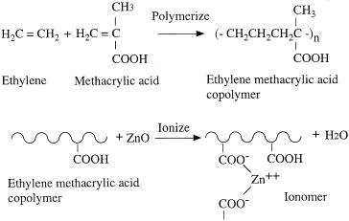

sulfonate ionomers is sulfonated tetrafluoroethylene (Nafion) which is produced by free-radical copolymerization of tetrafluoroethylene (TFE is the monomer of Teflon) with a per fluorinated vinyl ether sulfonyl fluoride co-monomer.

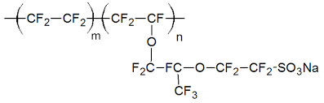

b.Post-functionalization of a standard pre-formed polymer
Post-functionalization of standard pre-formed polymers is a common used synthetic method provided that the polymer is reactive. Examples are the sulphonation of polystyrene and the grafting on to polybutadicne of thioglycollic acid using free radicals.
Post-functionalization of a special pre-formed polymer
Examples are sulphonatablc ethylene-propylene rubber and poly [arylcne-ether sulphone]. Using special post-functionalizable copolymers like this can also sometimes avoid the difficulties mentioned above of copolymerizing ionic and non-ionic monomers. To this end there are many examples where carboxy polymers arc formed by hydrolysing copolymers containing acrylatc esters, acrylonitrile or maleic anhydride. As described later, tetra- fluoroethylene copolymerizcd with a sulphonyl fluoride is hvdrolyscd to form a sulphonic acid ionomcr .
Carboxy polymers are probably the most common ionic polymers of all. Those which are used commercially are often made by the direct method and obtained in the acid form which is afterwards neutralized.

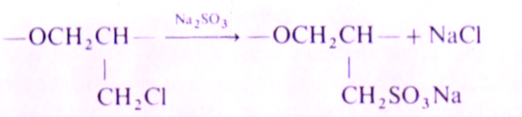

Properties
Synthetic ionic polymers have a vast range of physical properties but they have three distinctive features which dictate their usage: (a) ionic cross-linking; (b) ion-exchange capability; and (c) Hydrophilicity.

Ionic cross-linking
Ionic cross-linking expresses itself as a kind of phase separation on the molecular level. In an ionomers, the non polar chains are grouped together and the polar ionic groups are attracted to each other. They form very small clusters of just a few ionic groups surrounded by a sea of non-ionic polyethylene segments. This clustering acts like a physical crosslink and allows thermoplastic ionomers to act in ways similar to that of cross linked polymers.These crosslinks are thermally labile they can be broken on melting.So it can be melt processable
Ion-exchange

The property of ion-exchange has important consequences and three different types of application depend on it. They are (a) ion-exchange resins; (b) ion-exchange membranes; and (c) heterogeneous catalysis.
Ionic polymers contain two types of ion. those which are bound within the structure, and the counter ions which are free. A polyion immersed in a medium in which it is insoluble will exchange its counter ions for similar ions from the surrounding medium and an equilibrium will occur. Counter ions have free movement into and out of the polymer while ions of the same charge type as the bound ion do not.
Ion-exchange resins are insoluble beads of an ionic polymer. They are best known for their use in the conversion of tap water to 'distilled' water by the process of de-ionization. This works by contacting the water with two types of resin, one a polyacid and the other a polybasic, so that the net effect is to exchange M⁺ and X - from the tap water for H ⁺ and OH⁻ (i.e. H₂0) from the beads
An example of electrodialysis (Figure) saline water is fed to a dialyser and drinkable water collected continuously. The dialyser is an electrical cell divided into a series of sub-cells which are separated by alternate polyanion and polycation membranes The ions move under the influence of the applied.

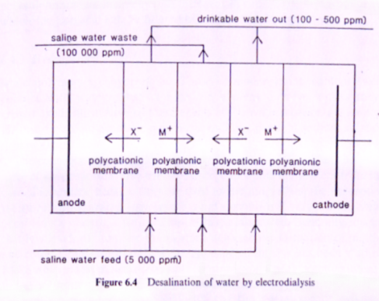
Another application in ionic exchange dialyser is shown in figer a simple dialysis process
Heterogeneous catalysis
Heterogeneous catalysisis another way in which the ion-exchange capability of ionicpolymers are exploited. Here the ionic polymer has to be insoluble, but swollen by the reactant solution. One example is dispersing polysulphonic acid in an aqueous mixture can catalyse certain reactions after which the polyacid can be filtered off, cleaned and recycled
Hydrophilicity
Ionic polymers are hydrophilic. Those of moderate ion content swell on contact with water; those of high ion content dissolve, unless they are cross-linked. Illustrative of these effects is the water uptake, on immersion for one day, of an aromatic polymer containing pendant sodium sulphonate groups (Table). Its properties and usefulness depend upon the ion content. In the case of ionomers, because they are used as thermoplastics, the absorption of moisture is undesirable.

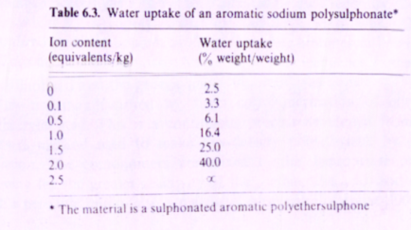
The majour Applications are
- Superabsorbent polymers (SAPs) (also called slush powder) are polymers that can absorb and retain extremely large amounts of a liquid relative to their own mass. Water-absorbing polymers, which are classified as hydrogels when cross-linked, absorb aqueous solutions through hydrogen bonding with water molecules.
- Reverse osmosis
A common application of reverse osmosis is the purification of water. In this process a saline, brackish water or sea water is forced at very high pressure through a hydrophilic membrane, and water of drinkable quality emerges (Figure).

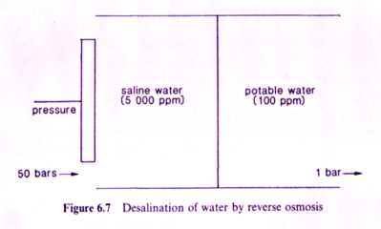

The term reverse osmosis arises because the natural osmotic pressure tends to force the water in the opposite direction (i.e. from the region of low ionic concentration to that of the high) and to achieve the desired flow the applied pressure has to exceed the osmotic pressure.
Unlike electrodialysis no electric current is applied, only application of preasure . An essential requirement of a membrane for reverse osmosis is hydrophilicity, although it need not be ionic.
- Polyelectrolytesapplications
Viscosity modifiers: Polyelectrolytes raise the viscosity of aqueous solutions and so act as thickeners, and the magnitude of the effect increases with the polymers.
Synthetic polyelectrolytes are also much used to modify the flow characteristics of latex paints and similar proprietary fluids
It have numerous applications too.
Structure, Preparation and Properties of Polystyrene Ionomers

Polystyrene when dissolved in concentrated sulphuric acid becomes highlysulphonated but it can be lightly sulphonated by treating its solution in 1,2-dichloroethane with small amounts of acetyl sulphate formed by mixing acetic anhydride and sulphuric acid
Polystyrene can be carboxylated by lithiation followed by treatment with carbon dioxide to form the lithium carboxylate which can then be ion-exchanged to the acid or other salt forms.

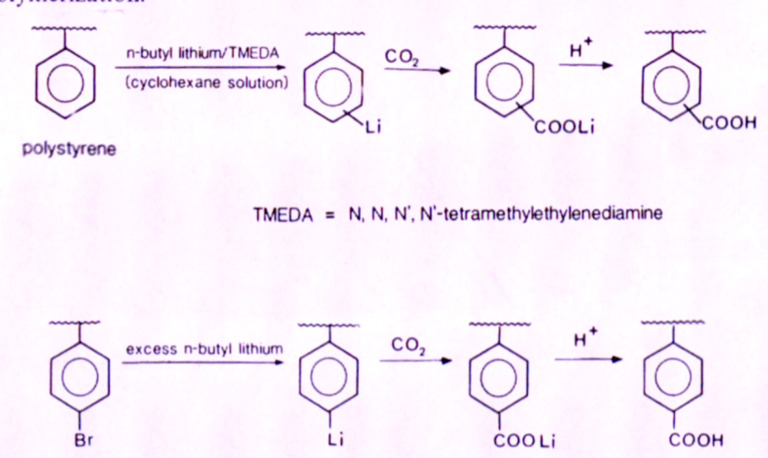
Properties
The ionomers of polystyrene show the usual characteristics of ionic polymers leading to multiplets and clusters.
A number of physical properties when plotted against increasing ionic content show discontinuities arising from the formation of first, multiplets, and then clusters.
Applications
Common applications of Polystyrene ionic polymers
- Drown-free water source for feeder insects
- Filtration applications
- Fragrance carrier ( Air freshner )
- Grow-in-water toys
- Ion exchange membranes

Structure, Preparation and Properties of Ionomers based on Polyaromatic backbones

Aromatic polyethersulphones are engineering-type thermoplastics with a phenylene backbone. They differ from polystyrene which has an aliphatic backbone. Currently, ionomers of polyethersulphones, principally sulphonates, are being developed as membranes, particularly for purifying water by reverse osmosis.
They distinguish themselves in this application by being resistant to oxidation by the chlorine used in water treatment, to biological fouling, to harsh chemical cleaning operations and to compaction under the high operating pressures.

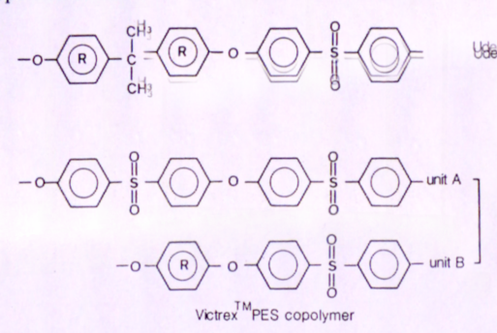

Preparation
The sulphonates are made by post-functionalization The precursor polymers are commercial-type plastics made by an ether-forming condensation of a bisphenol and a derivative of diphenyl sulphone. One of the two main types, when dissolved in dichloroethane and treated with a complex of sulphur trioxide and tri-ethyl phosphate, becomes monosulphonated on the rings marked 'R' (the rings connected to the sulphone group being deactivated by the sulphone group)
Poly [dimethylphenylene oxide] (PPO) was sulphonated in the early 1970s and evaluated in membrane applications.
The general physical properties of the sulphonated polysulphones show many of the characteristics of the simpler aliphatic ionomers and almost same as that of Aromatic polymers
Uses
Membranes
Iorn exchange applications
General applications of other Ionomers

Structure, Preparation and Properties of Ionomersbased on polytetrafluoroethylene (PTFE)

Polymers with a PTFE backbone and pendant perfluorosulphonate or perfluorocarboxylate groups have become important commercial materials? .The sulphonates are made by free radical copolymerization of TFE with vinyl monomers giving non-ionic precursor copolymers which can be post-functionalized by hydrolysis. The comonomers are themselves perfluorovinyl compounds and made from TFE by multi-step syntheses using hexafluoropropylene oxide.

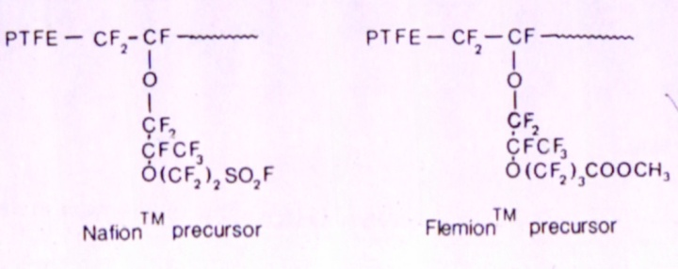
Properties
It was originally developed for use as a membrane in fuel cells but it has been more useful in various other electrolytic-separation processes. These applications exploit its cation-exchange properties and its ability to survive in extremely aggressive chemical environments.

The requirement for balancing the ionic content of an ion-exchange membrance with its perm selectivity and hydrophilicity is an essential requirement.
The performance of membranes in the chlor-alkali process is assessed by the efficiency with which power is consumed and the highest concentration of uncontaminated sodium hydroxide which can be produced. Rapid progress has been made in recent years, particularly since the introduction of carboxylate membranes, such that the efficiency is 95"„ and the concentration

Uses
Membrane in the chlor alkali cell .
Membrane in Reverse osmosis
Other general uses of ionic polymers This can be used .
Applications with heat resistance ionomer applications

Polyelectrolyte ion exchangers
Ion exchange is an exchange of ions between two electrolytes or between an electrolyte solution and a complex. In most cases the term is used to denote the processes of purification, separation, and decontamination of aqueous and other ion-containing solutions with solidpolymeric or mineralic 'ion exchangers'.
Typical ion exchangers are ion exchange resins (functionalized porous or gel polymer), zeolites, montmorillonite, clay, and soil humus. Ion exchangers are either cation exchangers that exchange positively charged ions (cations) or anion exchangers that exchange negatively charged ions (anions).

The resins used are highly ionic, Coovalently cross-linked, insoluble polyelectrolytes and are supplied as water-swellable beads which have either a dense internalPolystyrene (PS) cross-linked with about 8 mol % divinyl benzene (DVB) is the matrix on which most modern resins are based; the bound ions are pendant to the phenyl ring in the para position.
Ion exchange is an exchange of ions between two electrolytes or between an electrolyte solution and a complex. In most cases the term is used to denote the processes of purification, separation, and decontamination of aqueous and other ion-containing solutions with solidpolymeric or mineralic 'ion exchangers'.
Typical ion exchangers are ion exchange resins depending on their chemical structure. This can be dependent on the size of the ions, their charge, or their structure.
Viscosity modifieres
Polyelectrolytes raise the viscosity of aqueous solutions and so act as thickeners, and the magnitude of the effect increases with the polymers.
Synthetic polyelectrolytes are also much used to modify the flow characteristics of latex paints and similar proprietary fluids.
Polyelectrolytes will also stabilize particles in aqueous suspension thus actingas dispersants. prevents their growth into larger crystals.
Polyelectrolytes can also function as flocculating agents. In that role, depending on their ionic charge, they can interact with colloidal particles and neutralize the stabilizing hydrophilic charges. They have been used in this way to coagulate slurries and industrial wastes. In general the broad applications of polyelectrolytes may be listed as

- Composites and laminates
- Controlled release of drugs
- Controlled release of insecticides and herbicides
- Diapers and incontinence garments
- Drown-free water source for feeder insects
- Filtration applications
- Fire-retardant gel
- Flood control
- Fragrance carrier ( Air freshner )
- Frog tape (high tech masking tape designed for use with latex paint).
- Grow-in-water toys
- Hot & cold therapy packs
- Magical effects
- Medical waste solidification
- YinCheng's pads
- Motionless water beds
- Spill control
- Surgical pads
- Potting soil
- Waste stabilization and environmental remediation
- Water retention for supplying water to plants
- Wire and cable water blocking
- Wound dressings
- Fuel monitor systems in aviation
- Fuel monitor systems in vehicles
- Artificial snow
Nano polymers
3.2.1 Nano materials & Structure
3.2.2 Nano material processing & applications
Nano materials & Structure
Polymers comprising particles at least one dimension in the nano size range (1-100 nm)
This is a class of materials that have properties with significant commercial potential.
Polymer nano composites offer the possibility of developing new classes of materials with unique structure- property relationships. These nanostructure-property relationships are the frontier in nano composites.
Attractive features identified with nano composites are
Efficient reinforcement without loss of ductility and even improvement in impact strength
Excellent optical and altered electronic properties, heat stability, flame resistance, improved gas barrier properties, improved abrasion resistance, reduced shrinkage and residual stress.
Classification of nanomaterials
Three dimension
All the dimensions are in nanometer range eg. Nano silica
Two dimension
Two dimensions are in nanometer range,eg.wiskers or carbon nanotubes
Two dimension
One dimension is in the nanometer range, eg. Layered silicates or clays
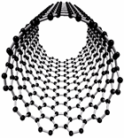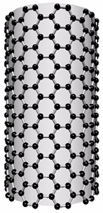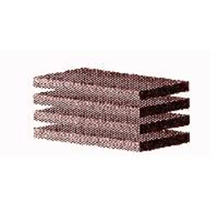
Three dimension Two dimension Two dimension
Processing
Conventional processing ( mixing, shapping , and curing if required ) with apropreate quantity of nano materials and other aterials are followed . For better properties special technics such as Intercalation and exfoliation are utilized . These are two majour type of distribution of nano aterial in polyer chain
Applications
Automobile, aircraft and space, biomedical, composits etc are applications

