UNIT II – Sustainable planning and design
Sustainable Development, Sustainable approach to site planning and design, site inventories, relationships between site factors, development impacts from one area of the site on the other areas, model ecosystem of the site, environmental monitoring and testing during construction , phasing of development, limits of change, design facility within social and environmental thresholds.
Introduction
Sustainability - derived from the latin sustinere
“ SUS + TENERE = UP + TO HOLD”
Brundtland Commission of the United Nations (March 20, 1987): “sustainable development is development that meets the needs of the present without compromising the ability of future generations to meet their own needs.”
The definition is based on two concepts:
- the concept of needs, comprising of the conditions for maintaining an acceptable life standard for all people
- the concept of limits of the capacity of the environment to fulfill the needs of the present and the future, determined by the state of technology and social organisation.

2005 World Summit - the "three pillars" of sustainability or (the 3 E's)
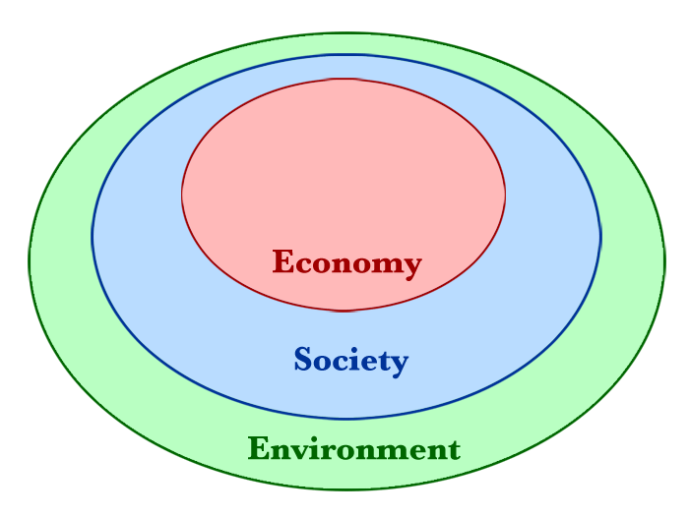

an illustration - three overlapping ellipses indicating that the three pillars of sustainability are not mutually exclusive and can be mutually reinforcing ( Triple bottom line)

Simple definition
Sustainability - improving the quality of human life while living within the carrying capacity of supporting eco-systems“
Circles of Sustainability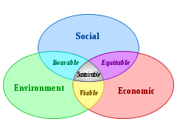
United Nations 2005 World Summit - "interdependent and mutually reinforcing pillars" of sustainable development as economic development, social development, and environmental protection.

Sustainable development – definitions
- Human activities that do not do permanent damage to the environment or rob resources from future generations
- Development that can be maintained in long term, without consuming or destroying finite resources
- Use of components of biological diversity in a way that does not interfere with the natural functioning of ecological process and life support systems
- Preservation and protection of diverse ecosystems

Why we have taken this path???
- We are interested only in short term benefits
- Implications of development – neglected
- Decision making process is top down approach
- Priorities of individuals and civil society are different

Principles towards sustainable development
- Documenting environmental resources
- Assessing their value in their long range economic socio cultural terms
- Pegging needs at reasonable needs
- Curbing wastage
- Optimization of existing facilities
- Ensuring equity
- Working for bottom up decision
- Full stakeholder involvement
- Good governance

DO what we can and should
- “As individuals
- As part of civil society
- As part of organizations and institutions”

Sustainable design (also called environmental design, environmentally sustainable design, environmentally conscious design, etc.) is the philosophy of designing physical objects, the built environment, and services to comply with the principles of social, economic, and ecological sustainability.

Sustainable design
Integrating architecture with
- Electrical + Mechanical + Structural
- traditional aesthetics – massing + proportion+ scale + texture + shadow + light
- Long term costs - environmental + economic + human.

Five elements for sustainable design (Rocky Mountain Institute)
- the greatest impact on energy efficiency, passive solar design, day lighting, and natural cooling.
- more of a philosophy of building
- Less cost & simple
- Integrated design- each component is considered part of a greater whole
- The organizing principles - Minimizing energy consumption and promoting human health

PRINCIPLES OF SUSTAINABLE DESIGN
- Economy of Resources is concerned with the reduction, reuse, and recycling of the natural resources that are input to a building.
- Life Cycle Design provides a methodology for analyzing the building process and its impact on the environment.
- Humane Design focuses on the interactions between humans and the natural world.

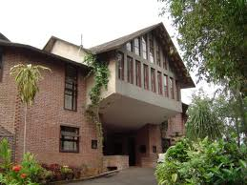
Understanding Place
- an intimate understanding of place.
- sensitive to the nuances of place
- solar orientation of a building on the site
- preservation of the natural environment
- and access to public transportation.
- Baker’s Centre for developmental studies
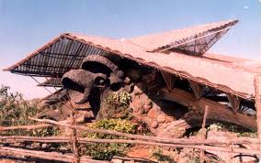
Connecting with Nature
- Whether the design site is a building in the inner city or in a more natural setting, connecting with nature brings the designed environment back to life.
- Effective design helps inform us of our place within nature.
- Nari Gandhi’s – weekend cottage, Lonavla

Understanding Natural Processes
- In nature there is no waste.
- The byproduct of one organism becomes the food for another.
- Engaging processes that regenerate rather than deplete, we become more alive.
Making natural cycles and processes visible brings the designed environment back to life
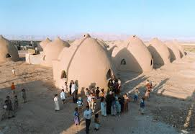
Understanding Environmental Impact
- the embodied energy and toxicity of the materials - low
- the energy efficiency of design, materials and construction techniques.
- Negative environmental impact can be mitigated through use of sustainably harvested building materials and finishes
- Materials - manufacturing and installation, and recycling building materials while on the job site
- Nader Khalili’s – Earth bag construction
Embracing Co-creative Design Processes
- Collaboration with systems consultants, engineers and other experts happens early in the design process
- listening to the voices of local communities.

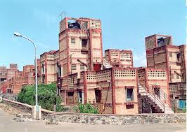
Understanding People
- the wide range of cultures, races, religions and habits of the people who are going to be using and inhabiting the built environment.
- This requires sensitivity and empathy on the needs of the people and the community.
- Belapur mass housing – cluster, incremental housing, economical
Benefits of Sustainable design
Parameter | Economic | Societal | Environmental
Siting | Reduced costs for site preparation, parking lots, roads | Improved aesthetics, more transportation options for employees | Land preservation, reduced resource use, protection of ecological resources, soil & water conservation, restoration of brown fields, reduced energy use, less air pollution
Water efficiency | Lower first cost, reduced annual water & waste water costs | Preservation of water resources for future generations and for agricultural & recreational uses, fewer wastewater treatment plants | Lower potable water use & reduced discharge to waterways, less strain on aquatic ecosystems in water short areas, preservation of water resources for wildlife & agriculture
Energy efficiency | Lower first costs, lower fuel & electricity costs, reduced peak power demand, reduced demand for new energy infrastructure | Improved comfort conditions for occupants, fewer new power plants & transmission lines | Lower electricity & fossil fuel use, less air pollution & fewer Co2 emissions, lowered impact from fossil fuel production & distribution
Materials & resources | Decreased first cost for reuse & recycled materials, lower waste disposal costs, reduced replacement costs for durable materials, reduction of need for new landfills | Fewer landfills, greater markets for environment preferable products, decreased traffic due to the use of local / regional materials | Reduced strain on landfills, better managed forests, reduced use of virgin resources, lower transportation energy & pollution, increase in recycling markets
Indoor air quality | Higher productivity, lower incidence of absenteeism, reduced staff turn over, lower insurance costs, reduced litigation | Reduced adverse health impacts, improved occupant comfort & satisfaction, better individual productivity | Better IAQ including reduced emissions of VOC, Co2, CO
Commissioning: operations & maintenance | Lower energy costs, reduced occupant/ owner complaints, longer building & equipment lifetimes | Improved occupant productivity, satisfaction, health & safety | Lower energy consumption, reduced air pollution & other emissions
Sustainable site planning – basics
Site Selection | Avoid flood plains  Avoid greenfields - greyfields and brownfields are often less expensive to develop, place less stress on infrastructure  Transportation - encourage the use of public and non-motorized transportation.
Site/Building Layout | Elongate the plan on the east/west axis  Maximize north and south exposure for daylighting  Minimize east and west facing windows  Orient most populated areas to the north and south
Landscape Design | - Limit potable water use  - Use Native Species  - Place landscape areas to receive runoff  - Use captured rainwater  - Shade large hardscapes  - Shade buildings in summer, allow sunlight in during winter  - Place and design landscape areas to filter and clean stormwater  - Raingardens in parking areas

Overview of building design issues

Passive solar design | Day lighting  Building envelope  Renewable energy
Building systems & IAQ | HVAC, electrical & plumbing system  IAQ  Acoustics  Building commissioning
Materials & Specifications | Materials  Specification

Design considerations & practices for sustainable building
- Resources should be used only at the speed at which they naturally regenerate.
- Material & energy resources – a part of a balanced human/ natural cycle
- Site planning –incorporate resources naturally available on site
- Resource efficient materials – reduces local & global impact
- Energy & materials waste should minimized in building’s life cycle form design through reuse or demolition
- Building shell – energy efficient
- Materials & design strategies – excellent total indoor environmental quality (IAQ)
- Design should maximize occupant health & productivity.
- O & M – support waste reduction & recycling
- Water – to be managed as a limited resource
- Location & systems – optimize employee commuting & customer transportation options & minimize the use of single occupancy vehicles.

Goal of site analysis
- To achieve a successful design, site analysis is a must & should be done carefully
- Site Analysis involves taking an inventory of site elements and analyzing these factors relative to the clients needs & aims
- Gather relevant information about the properties of the site, from topography to climate to wind pattern and vegetation
- Analyze these features and incorporate them into the design

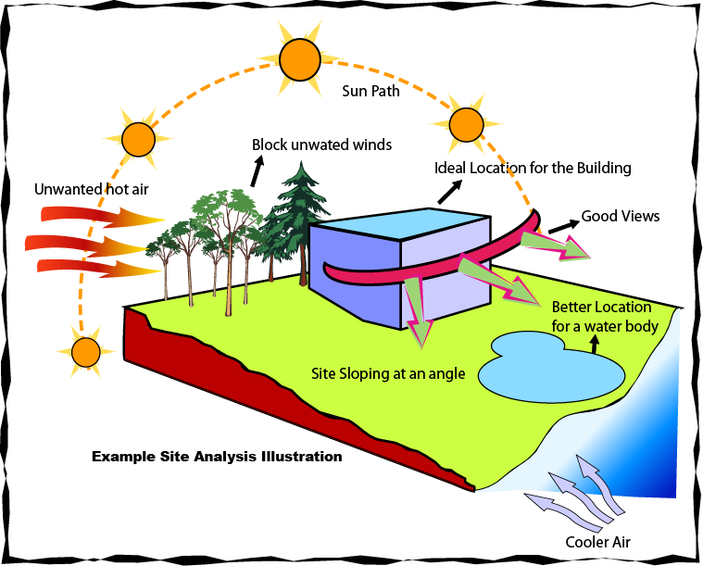
Example Site Condition

- Under Topography, 5 degree slope is noticed
- Analyzing the conditions, ideal location for building can be established
- High spot might be right for building & low spot for water body
- For prevailing hot winds, trees would act as buffer
- Openings in building could be placed to absorb cooler winds

Site Analysis: Inventory List

Subsurface Features
  - Geology: Geological history of the area, bedrock type & depth etc.
  - Hydrology: Underground water table, aquifers, springs etc.
  - Soil Genesis: erosion susceptibility, moisture (pF), reaction (pH) organic content, bearing capacity etc.
Natural Surface Features
- Vegetation: Type, size, location, shade pattern, aesthetics, ecology etc.
- Slopes: Gradient, landforms, elevations, drainage patterns
- Wild Life: ecology, species etc.
- Climate: precipitation, annual rain/snow, humidity, wind direction, solar intensity & orientation, average/highest/lowest temperature
- Natural Features: significant natural features of the site, water elements, rock formations, plant materials

Cultural & Man-made Features
  - Utilities: sanitary, water supply, gas, electrical etc.
  - Land use: Usage of site, adjacent use, zoning restrictions, easement etc.
  - Historic notes: archeological sites, landmarks, building type, size, condition
  - Circulation: linkages an transit roads, auto & pedestrian access, mass transit routes etc.
  - Social Factors: population, intensity, educational level, economic & political factors, ethnicity, cultural typology etc.

Aesthetic Factors:
  - Perceptual: from an auto, by pedestrian, by bike etc.
  - Spatial Pattern: views of the site, views from the site, spaces existing, potential for new areas, sequential relationship
Environmental monitoring – definition
"an activity undertaken to provide specific information on the characteristics and functions of environmental and social variables in space and time."

Principles of monitoring
- determine the indicators to be used in monitoring activities
- Collection of meaningful and relevant information
- Application of measurable criteria in relation to chosen indicators
- Reviewing objective judgments on the information collected
- Draw tangible conclusions based on the processing of information
- Making rational decision based on the conclusion drawn
- Recommendation of improved mitigation measures to be undertaken.
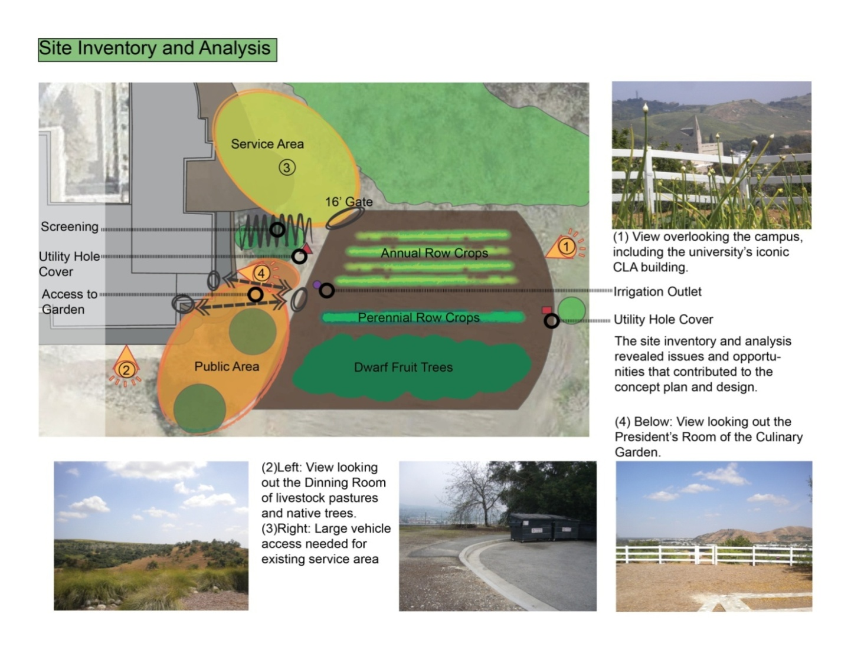
Site inventory
- It reflects the identification of the site’s critical features and relationships as determined by the particular perspective defined by both the landscape architect’s theoretical stance and the requirements of the specific project proposed.
- The inventory and analysis phase marks the first step in grounding the intangible, non-place-specific aims of the designer and the project in physical form.
Types of Monitoring
- Baseline Monitoring (pre-audit study)
  - A survey should be conducted on basic environmental parameters in the area surrounding the proposed project before construction begins.
- Impact Monitoring
- The biophysical and socio-economical (including public health) parameters within the project area, must be measured during the project construction and operational phases in order to detect environmental changes
- Compliance Monitoring
- this form of monitoring employs a periodic sampling method, or continuous recording of specific environmental quality indicators or pollution levels to ensure project compliance with recommended environmental protection standards.

Water Quality Impact
- Regular audit of implementation of the recommended mitigation measures during the construction phase at the works areas should also be undertaken during the construction phase to ensure the recommended mitigation measures are properly implemented.
- Groundwater monitoring on tunnel groundwater ingress is recommended from the engineering perspective during construction phase. Baseline data would be obtained prior to commencement of construction works.
- With the full implementation of the recommended mitigation measures during operation phase, no adverse water quality impact is anticipated.
- Operation phase water quality monitoring is not considered necessary.

Sewerage and Sewage Treatment Implications
- It is recommended to conduct regular monitoring of the quality of treated effluent discharged from the proposed sewage treatment work in order to ensure compliance with the no net increase in pollutant loading requirement as well as the relevant licence requirements under the Water Pollution Control Ordinance

Waste Management Implications
Waste management would be the contractor’s responsibility to ensure that all wastes produced during the construction phase are handled, stored and disposed of in accordance with good waste management practices

Land Contamination
During construction phase, EM&A is to be carried out in the form of regular site inspection. All related procedures and facilities for handling or storage of chemicals and chemical wastes should be audited regularly to make sure they are in order and intact and reported in the EM&A reports as such.

Ecological Impact
- The implementation of the transplanting of floral species of conservation interest and the provision of Woodland/ Wetland Compensation Area shall be checked during the routine site inspection. The inspection, observation and recommendation shall be reported

Fisheries Impact
- Pond fish culture resources and activities to be identified within the Study Area.

Landscape, Visual and Glare Impact
The design, implementation and maintenance of landscape and visual mitigation measures are key aspects of the Project and their implementation and maintenance should be checked to ensure that they are fully realized such that they mitigate landscape and visual impacts to their full potential.

Impact on Cultural Heritage
- During detail design stage of the Project, in case any potential vibration impact on any nearby built heritage features are identified due to the change of the Project design, it is recommended that prior to commencement of the construction works, a baseline condition survey and baseline vibration impact assessment should be conducted by a qualified building surveyor and a qualified structural engineer to define the vibration limit and to evaluate if construction vibration monitoring and structural strengthening measures are required during construction phase to ensure the construction performance meets with the vibration criteria

