Ancient Egyptian architecture
From Wikipedia, the free encyclopedia
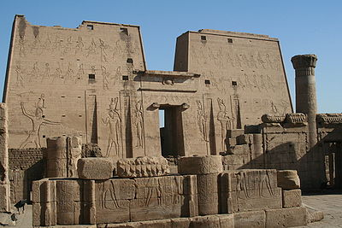
The well preserved Temple of Horus at Edfu is an example of Egyptian architecture and architectural sculpture.
Ancient Egyptian architecture is the architecture of ancient Egypt, one of the most influential civilizations throughout history, which developed a vast array of diverse structures and great architectural monuments along the Nile, among the largest and most famous of which are the Great Pyramid of Giza and the Great Sphinx of Giza.

Characteristics
Due to the scarcity of wood, the two predominant building materials used in ancient Egypt were sun-baked mud brick and stone, mainly limestone, but also sandstone and granite in considerable quantities.From the Old Kingdom onward, stone was generally reserved for tombs and temples, while bricks were used even for royal palaces, fortresses, the walls of temple precincts and towns, and for subsidiary buildings in temple complexes. The core of the pyramids came from stone quarried in the area already while the limestone, now eroded away, that was used to face the pyramids came from the other side of the Nile River and had to be quarried, ferried across, and cut during the dry season before they could be pulled into place on the pyramid.
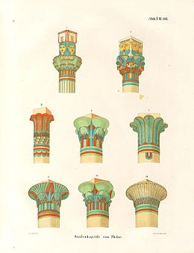
Drawings of the types of the architectural capitals specific for the Ancient Egyptian civilization.
Ancient Egyptian houses were made out of mud collected from the Nile river. It was placed in molds and left to dry in the hot sun to harden for use in construction.
Many Egyptian towns have disappeared because they were situated near the cultivated area of the Nile Valley and were flooded as the river bed slowly rose during the millennia, or the mud bricks of which they were built were used by peasants as fertilizer. Others are inaccessible, new buildings having been erected on ancient ones. Fortunately, the dry, hot climate of Egypt preserved some mud brick structures. Examples include the village Deir al-Madinah, the Middle Kingdom town at Kahun, and the fortresses at Buhen] and Mirgissa. Also, many temples and tombs have survived because they were built on high ground unaffected by the Nile flood and were constructed of stone.
Thus, our understanding of ancient Egyptian architecture is based mainly on religious monuments, massive structures characterized by thick, sloping walls with few openings, possibly echoing a method of construction used to obtain stability in mud walls. In a similar manner, the incised and flatly modeled surface adornment of the stone buildings may have derived from mud wall ornamentation. Although the use of the arch was developed during the fourth dynasty, all monumental buildings are post and lintel constructions, with flat roofs constructed of huge stone blocks supported by the external walls and the closely spaced columns.
Exterior and interior walls, as well as the columns and piers, were covered with hieroglyphic and pictorial frescoes and carvings painted in brilliant colors Many motifs of Egyptian ornamentation are symbolic, such as the scarab, or sacred beetle, the solar disk, and the vulture. Other common motifs include palm leaves, the papyrus plant, and the buds and flowers of the lotus.^{[8]} Hieroglyphs were inscribed for decorative purposes as well as to record historic events or spells. In addition, these pictorial frescoes and carvings allow us to understand how the Ancient Egyptians lived, statuses, wars that were fought and their beliefs. This was especially true when exploring the tombs of Ancient Egyptian officials in recent years.
Ancient Egyptian temples were aligned with astronomically significant events, such as solstices and equinoxes, requiring precise measurements at the moment of the particular event. Measurements at the most significant temples may have been ceremonially undertaken by the Pharaoh himself.[

The Giza pyramid complex
The Giza Necropolis stands on the Giza Plateau, on the outskirts of Cairo, Egypt. This complex of ancient monuments is located some 8 kilometres (5 mi) inland into the desert from the old town of Giza on the Nile, some 20 kilometers (12 mi) southwest of Cairo city center. This Ancient Egyptian necropolis consists of the Pyramid of Khufu (also known as the Great Pyramid and the Pyramid of Cheops), the somewhat smaller Pyramid of Khafre (or Kephren/Chefren), and the relatively modest-sized Pyramid of Menkaure (or Mykerinus/Mycerinus), along with a number of smaller satellite edifices, known as "queens" pyramids, and the Great Sphinx.^{[10]}
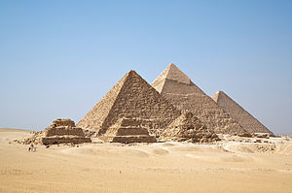
The Pyramids of Giza
The pyramids, which were built in the Fourth Dynasty, testify to the power of the pharaonic religion and state. They were built to serve both as grave sites and also as a way to make their names last forever The size and simple design show the high skill level of Egyptian design and engineering on a large scale.[ The Great Pyramid of Giza, which was probably completed c. 2580 BC, is the oldest and largest of the pyramids, and is the only surviving monument of the Seven Wonders of the Ancient World. The pyramid of Khafre is believed to have been completed around 2532 BC, at the end of Khafre's reign Khafre ambitiously placed his pyramid next to his fathers. It is not as tall as his father's pyramid but he was able to give it the impression of appearing taller by building it on a site with a foundation 33 feet higher than his father's. Along with building his pyramid, Chefren commissioned the building of the giant Sphinx as guardian over his tomb. The face of a human, possibly a depiction of the pharaoh, on a lion's body was seen as a symbol of divinity among the Greeks fifteen hundred years later. The Great Sphinx is carved out of huge blocks of sandstone and stands about sixty-five feet tall.[ Menkaure's pyramid dates to circa 2490 BC and stands 213 feet high making it the smallest of the Great Pyramids.
Popular culture leads people to believe that Pyramids are highly confusing, with many tunnels within the pyramid to create confusion for grave robbers. This is not true. The shafts of pyramids are quite simple, mostly leading directly to the tomb. The immense size of the pyramids attracted robbers to the wealth that lay inside which caused the tombs to be robbed relatively soon after the tomb was sealed in some cases. However, there are sometimes additional tunnels, but these were used for the builders to understand how far they could dig the tomb into the crust of the Earth. Also, it is popular thought that due to grave robbers, future Kings were buried in the Valley of the Kings to help keep them hidden. This is also false, as the Pyramid construction continued for many Dynasties, just on a smaller scale. Finally, the pyramid construction was stopped due to economic factors, not theft.
It is widely believed that the pyramids were able to be constructed due to slave labor. Some scholars believe that they were essentially built by farmers during the off season. Either way, the pyramids represent a lifestyle of the nobles that could not exist without the presence of slave labor.
Karnak
Main article: Karnak
The temple complex of Karnak is located on the banks of the River Nile some 2.5 kilometers (1.5 mi) north of Luxor. It consists of four main parts, the Precinct of Amon-Re, the Precinct of Montu, the Precinct of Mut and the Temple of Amenhotep IV (dismantled), as well as a few smaller temples and sanctuaries located outside the enclosing walls of the four main parts, and several avenues of ram-headed sphinxes connecting the Precinct of Mut, the Precinct of Amon-Re and Luxor Temple.
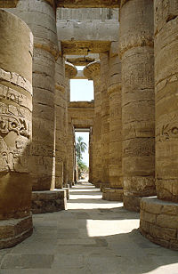
The hypostyle hall of Karnak Temple
The key difference between Karnak and most of the other temples and sites in Egypt is the length of time over which it was developed and used. Construction work began in the 16th century BC. Approximately 30 pharaohs contributed to the buildings, enabling it to reach a size, complexity and diversity not seen elsewhere. Few of the individual features of Karnak are unique, but the size and number of features is overwhelming.

Luxor Temple
Main article: Luxor Temple
The Luxor Temple is a huge ancient Egyptian temple complex located on the east bank of the River Nile in the city today known as Luxor (ancient Thebes). Construction work on the temple began during the reign of Amenhotep III in the 14th century BC. Horemheb and Tutankhamun added columns, statues, and friezes – and Akhenaten had earlier obliterated his father's cartouches and installed a shrine to the Aten – but the only major expansion effort took place under Ramesses II some 100 years after the first stones were put in place. Luxor is thus unique among the main Egyptian temple complexes in having only two pharaohs leave their mark on its architectural structure.
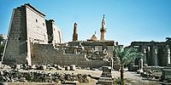
Luxor Temple, from the east bank of the Nile
The temple proper begins with the 24 metre (79 ft) high First Pylon, built by Ramesses II. The pylon was decorated with scenes of Ramesses's military triumphs (particularly the Battle of Qadesh); later pharaohs, particularly those of the Nubian and Ethiopian dynasties, also recorded their victories there. This main entrance to the temple complex was originally flanked by six colossal statues of Ramesses – four seated, and two standing – but only two (both seated) have survived. Modern visitors can also see a 25 metre (82 ft) tall pink granite obelisk: this one of a matching pair until 1835, when the other one was taken to Paris where it now stands in the centre of the Place de la Concorde.
Through the pylon gateway leads into a peristyle courtyard, also built by Ramesses II. This area, and the pylon, were built at an oblique angle to the rest of the temple, presumably to accommodate the three pre-existing barque shrines located in the northwest corner. After the peristyle courtyard comes the processional colonnade built by Amenhotep III – a 100 metre (328 ft) corridor lined by 14 papyrus-capital columns. Friezes on the wall describe the stages in the Opet Festival, from sacrifices at Karnak at the top left, through Amun's arrival at Luxor at the end of that wall, and concluding with his return on the opposite side. The decorations were put in place by Tutankhamun: the boy pharaoh is depicted, but his names have been replaced with those of Horemheb.
Beyond the colonnade is a peristyle courtyard, which also dates back to Amenhotep's original construction. The best preserved columns are on the eastern side, where some traces of original colour can be seen. The southern side of this courtyard is made up of a 36-column hypostyle court that leads into the inner sanctums of the temple, which begin with a dark chamber not achechamber.

Ancient Greek architecture
From Wikipedia, the free encyclopedia
Jump to: navigation, search
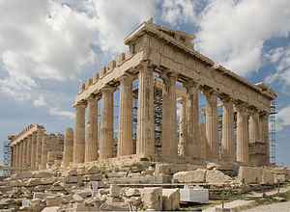
The Parthenon under restoration in 2008
The architecture of Ancient Greece is the architecture produced by the Greek-speaking people (Hellenic people) whose culture flourished on the Greek mainland and Peloponnesus, the Aegean Islands, and in colonies in Asia Minor and Italy for a period from about 900 BC until the 1st century AD, with the earliest remaining architectural works dating from around 600 BC.[
Ancient Greek architecture is best known from its temples, many of which are found throughout the region, mostly as ruins but many substantially intact. The second important type of building that survives all over the Hellenic world is the open-air theatre, with the earliest dating from around 350 BC. Other architectural forms that are still in evidence are the processional gateway (propylon), the public square (agora) surrounded by storied colonnade (stoa), the town council building (bouleuterion), the public monument, the monumental tomb (mausoleum) and the stadium.
Ancient Greek architecture is distinguished by its highly formalised characteristics, both of structure and decoration. This is particularly so in the case of temples where each building appears to have been conceived as a sculptural entity within the landscape, most often raised on high ground so that the elegance of its proportions and the effects of light on its surfaces might be viewed from all angles.^{[2]} Nikolaus Pevsner refers to "the plastic shape of the [Greek] temple.....placed before us with a physical presence more intense, more alive than that of any later building".]
The formal vocabulary of Ancient Greek architecture, in particular the division of architectural style into three defined orders: the Doric Order, the Ionic Order and the Corinthian Order, was to have profound effect on Western architecture of later periods. The architecture of Ancient Rome grew out of that of Greece and maintained its influence in Italy unbroken until the present day. From the Renaissance, revivals of Classicism have kept alive not only the precise forms and ordered details of Greek architecture, but also its concept of architectural beauty based on balance and proportion. The successive styles of Neoclassical architecture and Greek Revival architecture followed and adapted Ancient Greek styles closely.

Types of buildings
Main articles: Ancient Greek temple, Ancient Greek theatre, Acropolis, Agora, and Stoa
The rectangular temple is the most common and best-known form of Greek public architecture. The temple did not serve the same function as a modern church, since the altar stood under the open sky in the temenos or sacred precinct, often directly before the temple. Temples served as the location of a cult image and as a storage place or strong room for the treasury associated with the cult of the god in question,, and as a place for devotees of the god to leave their votive offerings, such as statues, helmets and weapons. Some Greek temples appear to have been oriented astronomically. The temple was generally part of a religious precinct known as the acropolis. According to Aristotle, '"the site should be a spot seen far and wide, which gives good elevation to virtue and towers over the neighbourhood" Small circular temples, tholos were also constructed, as well as small temple-like buildings that served as treasuries for specific groups of donors.
During the late 5th and 4th centuries BC, town planning became an important consideration of Greek builders, with towns such as Paestum and Priene being laid out with a regular grid of paved streets and an agora or central market place surrounded by a colonnade or stoa. The completely restored Stoa of Attalos can be seen in Athens. Towns were also equipped with a public fountain house, where water could be collected for household use. The development of regular town plans is associated with Hippodamus of Miletus, a pupil of Pythagoras.
Public buildings became "dignified and gracious structures", and were sited so that they related to each other architecturally. The propylon or porch, formed the entrance to temple sanctuaries and other significant sites with the best-surviving example being the Propylaea on the Acropolis of Athens. The bouleuterion was a large public building with a hypostyle hall that served as a court house and as a meeting place for the town council (boule). Remnants of bouleuterion survive at Athens, Olympia and Miletus, the latter having held up to 1200 people.
Every Greek town had an open-air theatre. These were used for both public meetings as well as dramatic performances. The theatre was usually set in a hillside outside the town, and had rows of tiered seating set in a semicircle around the central performance area, the orchestra. Behind the orchestra was a low building called the skênê, which served as a store-room, a dressing-room, and also as a backdrop to the action taking place in the orchestra. A number of Greek theatres survive almost intact, the best known being at Epidaurus, by the architect Polykleitos the Younger.
Greek towns of substantial size also had a palaestra or a gymnasium, the social centre for male citizens which included spectator areas, baths, toilets and club rooms.[ Other buildings associated with sports include the hippodrome for horse racing, of which only remnants have survived, and the stadium for foot racing, 600 feet in length, of which examples exist at Olympia, Delphi, Epidarus and Ephesus, while the Panathinaiko Stadium in Athens, which seats 45,000 people, was restored in the 19th century and was used in the 1896, 1906 and 2004 Olympic Games.

Column and lintel
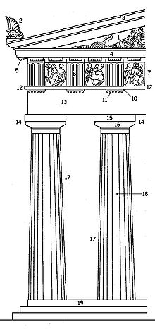
Parts of an Ancient Greek temple of the Doric Order:
1. Tympanum, 2. Acroterium, 3. Sima 4. Cornice 5. Mutules 7. Freize 8. Triglyph 9. Metope 10. Regula 11. Gutta 12. Taenia 13. Architrave 14. Capital 15. Abacus 16. Echinus 17. Column 18. Fluting 19. Stylobate
The architecture of Ancient Greece is of a trabeated or "post and lintel" form, i.e. it is composed of upright beams (posts) supporting horizontal beams (lintels). Although the existent buildings of the era are constructed in stone, it is clear that the origin of the style lies in simple wooden structures, with vertical posts supporting beams which carried a ridged roof. The posts and beams divided the walls into regular compartments which could be left as openings, or filled with sun dried bricks, lathes or straw and covered with clay daub or plaster. Alternately, the spaces might be filled with rubble. It is likely that many early houses and temples were constructed with an open porch or "pronaos" above which rose a low pitched gable or pediment.
The earliest temples, built to enshrine statues of deities, were probably of wooden construction, later replaced by the more durable stone temples many of which are still in evidence today. The signs of the original timber nature of the architecture were maintained in the stone buildings.
A few of these temples are very large, with several, such as the Temple of Zeus Olympus and the Olympieion at Athens being well over 300 feet in length, but most were less than half this size. It appears that some of the large temples began as wooden constructions in which the columns were replaced piecemeal as stone became available. This, at least was the interpretation of the historian Pausanias looking at the Temple of Hera at Olympia in the 2nd century AD.
The stone columns are made of a series of solid stone cylinders or “drums” that rest on each other without mortar, but were sometimes centred with a bronze pin. The columns are wider at the base than at the top, tapering with an outward curve known as “entasis”. Each column has a capital of two parts, the upper, on which rests the lintels, being square and called the “abacus”. The part of the capital that rises from the column itself is called the “echinus”. It differs according to the order, being plain in the Doric Order, fluted in the Ionic and foliate in the Corinthian. Doric and usually Ionic capitals are cut with vertical grooves known as “fluting”. This fluting or grooving of the columns is a retention of an element of the original wooden architecture

[Entablature and pediment
The columns of a temple support a structure that rises in two main stages, the entablature and the pediment.
The entablature is the major horizontal structural element supporting the roof and encircling the entire building. It is composed by three parts. Resting on the columns is the architrave made of a series of stone “lintels” that spanned the space between the columns, and meet each other at a joint directly above the centre of each column.
Above the architrave is a second horizontal stage called the “frieze”. The frieze is one of the major decorative elements of the building and carries a sculptured relief. In the case of Ionic and Corinthian architecture, the relief decoration runs in a continuous band, but in the Doric Order, it is divided into sections called “metopes” which fill the spaces between vertical rectangular blocks called “triglyphs”. The triglyphs are vertically grooved like the Doric columns, and retain the form of the wooden beams that would once have supported the roof.
The upper band of the entablature is called the “cornice”, which is generally ornately decorated on its lower edge. The cornice retains the shape of the beams that would once have supported the wooden roof at each end of the building. At the front and back of each temple, the entablature supports a triangular structure called the “pediment”. The triangular space framed by the cornices is the location of the most significant sculptural decoration on the exterior of the building.

Masonry
Every temple rested on a masonry base called the crepidoma, generally of three steps, of which the upper one which carried the columns was the stylobate. Masonry walls were employed for temples from about 600 BC onwards. Masonry of all types was used for Ancient Greek buildings, including rubble, but the finest ashlar masonry was usually employed for temple walls, in regular courses and large sizes to minimise the joints.[] The blocks were rough hewn and hauled from quarries to be cut and bedded very precisely, with mortar hardly ever being used. Blocks, particularly those of columns and parts of the building bearing loads were sometimes fixed in place or reinforced with iron clamps, dowels and rods of wood, bronze or iron fixed in lead to minimise corrosion.[

Openings
Door and window openings were spanned with a lintel, which in a stone building limited the possible width of the opening. The distance between columns was similarly affected by the nature of the lintel, columns on the exterior of buildings and carrying stone lintels being closer together than those on the interior, which carried wooden lintels. Door and window openings narrowed towards the top. Temples were constructed without windows, the light to the naos entering through the door. It has been suggested that some temples were lit from openings in the roof. A door of the Ionic Order at the Erechtheion, (17 feet high and 7.5 feet wide at the top), retains many of its features intact, including mouldings, and an entablature supported on console brackets. (See Architectural Decoration, below)
Structure, masonry, openings and roof of Greek temples
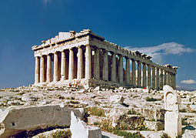
The Parthenon, shows the common structural features of Ancient Greek architecture: crepidoma, columns, entablature, pediment.
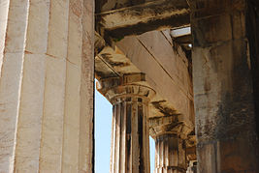
Temple of Hephaestos, fluted Doric columns with abacuses supporting double beams of the architrave
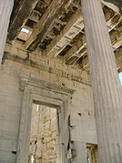
Erechtheion: masonry, door, stone lintels, coffered ceiling panels
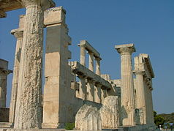
At the Temple of Aphaia the hypostyle columns rise in two tiers, to a height greater than the walls,

Roof
The widest span of a temple roof was across the cella, or internal space. In a large building, this space contains columns to support the roof, the architectural form being known as hypostyle. It appears that, although the architecture of Ancient Greece was initially of wooden construction, the early builders did not have the concept of the diagonal truss as a stabilising member. This is evidenced by the nature of temple construction in the 6th century BC, where the rows of columns supporting the roof the cella rise higher than the outer walls, unnecessary if roof trusses are employed as an integral part of the wooden roof. The indication is that initially all the rafters were supported directly by the entablature, walls and hypostyle, rather than on a trussed wooden frame, which came into use in Greek architecture only in the 3rd century BC.
Ancient Greek buildings of timber, clay and plaster construction were probably roofed with thatch. With the rise of stone architecture came the appearance of fired ceramic roof tiles. These early roof tiles showed an S-shape, with the pan and cover tile forming one piece. They were much larger than modern roof tiles, being up to 90 cm (35.43 in) long, 70 cm (27.56 in) wide, 3–4 cm (1.18–1.57 in) thick and weighing around 30 kg apiece. Only stone walls, which were replacing the earlier mudbrick and wood walls, were strong enough to support the weight of a tiled roof.
The earliest finds of roof tiles of the Archaic period in Greece are documented from a very restricted area around Corinth, where fired tiles began to replace thatched roofs at the temples of Apollo and Poseidon between 700 and 650 BC. Spreading rapidly, roof tiles were within fifty years in evidence for a large number of sites around the Eastern Mediterranean, including Mainland Greece, Western Asia Minor, Southern and Central Italy. Being more expensive and labour-intensive to produce than thatch, their introduction has been explained by the fact that their fireproof quality would have given desired protection to the costly temples. As a side-effect, it has been assumed that the new stone and tile construction also ushered in the end of overhanging eaves in Greek architecture, as they made the need for an extended roof as rain protection for the mudbrick walls obsolete.
Vaults and arches were not generally used, but begin to appear in tombs (in a "beehive" or cantilevered form such as used in Mycenaea) and occasionally, as an external feature, exedrae of voussoired construction from the 5th century BC. The dome and vault never became significant structural features, as they were to become in Ancient Roman architecture.^{[7]}

Temple plans
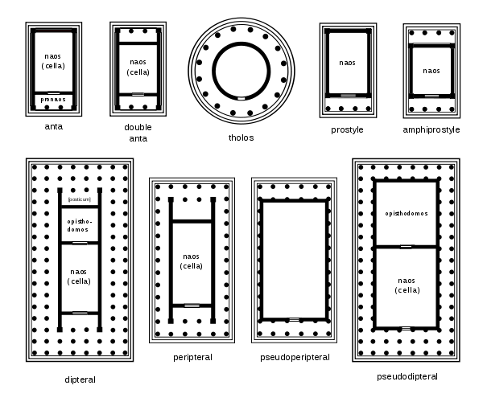
Plans of Ancient Greek Temples
Top: 1. distyle in antis, 2. amphidistyle in antis, 3. tholos, 4. prostyle tetrastyle, 5. amphiprostyle tetrastyle,
Bottom: 6. dipteral octastyle, 7. peripteral hexastyle, 8. pseudoperipteral hexastyle, 9. pseudodipteral octastyle
Most Ancient Greek temples were rectangular, and were approximately twice as long as they were wide, with some notable exceptions such as the enormous Temple of Zeus Olympus in Athens with a length of nearly 2 1/2 times its width. The majority of Temples were small, being 30–100 feet long, while a few were large, being over 300 feet long and 150 feet wide. The iconic Parthenon on the Athenian Acropolis occupies a midpoint at 235 feet long by 109 feet wide. A number of surviving temple-like structures are circular, and are referred to as tholos.
The temple rises from a stepped base or "stylobate", which elevated the structure above the ground on which it stood. Early examples, such as the Temple of Zeus at Olympus, have two steps, but the majority, like the Parthenon, have three, with the exceptional example of the Temple of Apollo at Didyma having six.] The core of the building is a masonry-built "naos" within which was a cella, a windowless room which housed the statue of the god. The cella generally had a porch or "pronaos" before it, and perhaps a second chamber or "antenaos" serving as a treasury or repository for trophies and gifts. The chambers were lit by a single large doorway, fitted with a wrought iron grill. Some rooms appear to have been illuminated by skylights.
On the stylobate, often completely surrounding the naos, stood rows of columns. Each temple was defined as being of a particular type, with two terms: one describing the number of columns across the entrance front, and the other defining their distribution.
Examples:
- Distyle in antis describes a small temple with two columns at the front, which are set between the projecting walls of the pronaos or porch, like the Temple of Nemesis at Rhamnus. (see left, figure 1.)
- Amphiprostyle tetrastyle describes a small temple that has columns at both ends which stand clear of the naos. Tetrastyle indicates that the columns are four in number, like those of the Temple on the Ilissus in Athens. (figure 4.)
- Peripteral hexastyle describes a temple with a single row of peripheral columns around the naos, with six columns across the front, like the Theseion in Athens. (figure 7.)
- Peripteral octastyle describes a temple with a single row of columns around the naos, (figure 7.) with eight columns across the front, like the Parthenon, Athens. (figs. 6 and 9.)
- Dipteral decastyle describes the huge temple of Apollo at Didyma, with the naos surrounded by a double row of columns, (figure 6.) with ten columns across the entrance front.
- The Temple of Zeus Olympius at Agrigentum, is termed Pseudo-periteral heptastyle, because its encircling colonnade has pseudo columns that are attached to the walls of the naos. (figure 8.) Heptastyle means that it has seven columns across the entrance front.

Proportion and optical illusion
The ideal of proportion that was used by Ancient Greek architects in designing temples was not a simple mathematical progression using a square module. The math involved a more complex geometrical progression, the so-called Golden mean. The ratio is similar to that of the growth patterns of many spiral forms that occur in nature such as rams' horns, nautilus shells, fern fronds, and vine tendrils and which were a source of decorative motifs employed by Ancient Greek architects as particularly in evidence in the volutes of capitals of the Ionic and Corinthian Orders
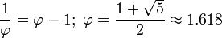
The Ancient Greek architects took a philosophic approach to the rules and proportions. The determining factor in the mathematics of any notable work of architecture was its ultimate appearance. The architects calculated for perspective, for the optical illusions that make edges of objects appear concave and for the fact that columns that are viewed against the sky look different to those adjacent that are viewed against a shadowed wall. Because of these factors, the architects adjusted the plans so that the major lines of any significant building are rarely straight.The most obvious adjustment is to the profile of columns, which narrow from base to top. However, the narrowing is not regular, but gently curved so that each columns appears to have a slight swelling, called entasis below the middle. The entasis is never sufficiently pronounced as to make the swelling wider than the base; it is controlled by a slight reduction in the rate of decrease of diameter
The Parthenon, the Temple to the Goddess Athena on the Acropolis in Athens, is the epitome of what Nikolaus Pevsner called "the most perfect example ever achieved of architecture finding its fulfilment in bodily beauty".Helen Gardner refers to its "unsurpassable excellence", to be surveyed, studied and emulated by architects of later ages. Yet, as Gardner points out, there is hardly a straight line in the building. Banister Fletcher calculated that the stylobate curves upward so that its centres at either end rise about 2.6 inches above the outer corners, and 4.3 inches on the longer sides. A slightly greater adjustment has been made to the entablature. The columns at the ends of the building are not vertical but are inclined towards the centre, with those at the corners being out of plumb by about 2.6 inches. These outer columns are both slightly wider than their neighbours and are slightly closer than any of the others.
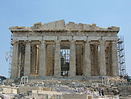
The main lines of the Parthenon are all curved.
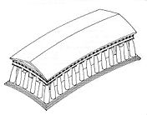
Digram showing the optical corrections made by the architects of the Parthenon
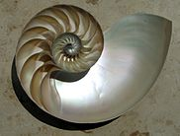
A sectioned nautilus shell. These shells may have provided inspiration for voluted Ionic capitals.
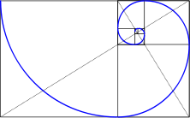
The growth of the nautilus corresponds to the Golden Mean

Style

Orders
Stylistically, Ancient Greek architecture is divided into three “orders”: the Doric Order, the Ionic Order and the Corinthian Order, the names reflecting their origins. While the three orders are most easily recognizable by their capitals, the orders also governed the form, proportions, details and relationships of the columns, entablature, pediment and the stylobate.^{[2]} The different orders were applied to the whole range of buildings and monuments.
The Doric Order developed on mainland Greece and spread to Italy. It was firmly established and well-defined in its characteristics by the time of the building of the Temple of Hera at Olympia, c. 600 BC. The Ionic order co-existed with the Doric, being favoured by the Greek cites of Ionia, in Asia Minor and the Aegean Islands. It did not reach a clearly defined form until the mid 5th century BC.^{[23]} The early Ionic temples of Asia Minor were particularly ambitious in scale, such as the Temple of Artemis at Ephesus.^{[11]} The Corinthian Order was a highly decorative variant not developed until the Hellenistic period and retaining many characteristics of the Ionic. It was popularised by the Romans.^{[7]}
Orders of Ancient Greek architecture
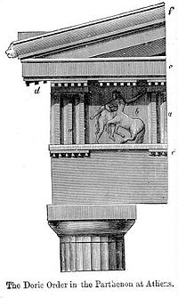
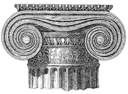
above: Capital of the Ionic Order showing volutes and ornamented echinus
left: Architectural elements of the Doric Order showing simple curved echinus of capital
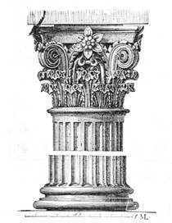
above: Capital of the Corinthian Order showing foliate decoration and vertical volutes.

Doric Order
The Doric order is recognised by its capital, of which the echinus is like a circular cushion rising from the top of the column to the square abacus on which rest the lintels. The echinus appears flat and splayed in early examples, deeper and with greater curve in later, more refined examples, and smaller and straight-sided in Hellenistc examples.^{[36]} A refinement of the Doric Column is the entasis, a gentle convex swelling to the profile of the column, which prevents an optical illusion of concavity.^{[36]}
Doric columns are almost always cut with grooves, known as "fluting", which run the length of the column and are usually 20 in number, although sometimes fewer. The flutes meet at sharp edges called arrises. At the top of the columns, slightly below the narrowest point, and crossing the terminating arrises, are three horizontal grooves known as the hypotrachelion. Doric columns have no bases, until a few examples in the Hellenistic period.^{[36]}
The columns of an early Doric temple such as the Temple of Apollo at Syracuse, Sicily, may have a height to base diameter ratio of only 4:1 and a column height to entablature ratio of 2:1, with relatively crude details. A column height to diameter of 6:1 became more usual, while the column height to entablature ratio at the Parthenon is about 3:1. During the Hellenistic period, Doric conventions of solidity and masculinity dropped away, with the slender and unfluted columns reaching a height to diameter ratio of 7.5:1.^{[36]}
The Doric Order
The Temple of Hephaestos, Athens, is a well-preserved temple of peripteral hexastyle plan.
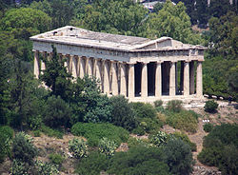
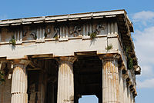
The entablature showing the architrave, frieze with triglyphs and metopes and the overhanging cornice
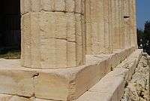
The tapered fluted columns, constructed in drums, rest directly on the stylobate.
The Doric entablature is in three parts, the architrave, the frieze and the cornice. The architrave is composed of the stone lintels which span the space between the columns, with a joint occurring above the centre of each abacus. On this rests the frieze, one of the major areas of sculptural decoration. The frieze is divided into triglyphs and metopes, the triglyphs, as stated elsewhere in this article, are a reminder of the timber history of the architectural style. Each triglyph has three vertical grooves, similar to the columnar fluting, and below them, seemingly connected, are small strips that appear to connect the triglyphs to the architrave below. A triglyph is located above the centre of each capital, and above the centre of each lintel. However, at the corners of the building, the triglyphs do not fall over the centre the column. The ancient architects took a pragmatic approach to the apparent "rules", simply extending the width of the last two metopes at each end of the building.
The cornice is a narrow jutting band of complex moulding which overhangs and protects the ornamented frieze, like the edge of an overhanging wooden-framed roof. It is decorated on the underside with projecting blocks, mutules, further suggesting the wooden nature of the prototype. At either end of the building the pediment rises from the cornice, framed by moulding of similar form
The pediment is decorated with figures that are in relief in the earlier examples, but almost freestanding by the time of the Parthenon. Early architectural sculptors found difficulty in creating satisfactory sculptural compositions in the tapering triangular space.[ By the Early Classical period, with the decoration of the temple of Zeus at Olympia, (486-460 BC) the sculptors had solved the problem by having a standing central figure framed by rearing centaurs and fighting men who are falling, kneeling and lying in attitudes that fit the size and angle of each part of the space.[ The renowned sculptor Phidias fills the space at the Parthenon (448-432 BC) with a complex array of draped and undraped figures of deities who appear in attitudes of sublime relaxation and elegance.

Ionic Order
The Ionic Order is recognised by its voluted capital, in which a curved echinus of similar shape to that of the Doric Order, but decorated with stylised ornament, is surmounted by a horizontal band that scrolls under to either side, forming spirals or volutes similar to those of the nautilus shell or ram's horn. In plan, the capital is rectangular. It's designed to be viewed frontally but the capitals at the corners of buildings are modified with an additional scroll so as to appear regular on two adjoining faces. In the Hellenistic period, four-fronted Ionic capitals became common.[
The Ionic Order
The Erechtheum, Acropolis, Athens: a building of asymmetrical plan, for the display of offerings to Athena
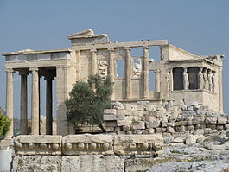
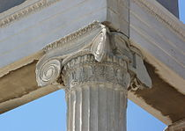
Corner capital with a diagonal volute, showing also details of the fluting separated by fillets.
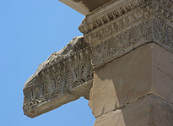
Frieze of stylised alternating palms and reeds, and a cornice decorated with "egg and dart" moulding.
Like the Doric Order, the Ionic Order retains signs of having ts origins in wooden architecture. The horizontal spread of a flat timber plate across the top of a column is a common device in wooden construction, giving a thin upright a wider area on which to bear the lintel, while at the same time reinforcing the load-bearing strength of the lintel itself. Likewise, the columns always have bases, a necessity in wooden architecture to spread the load and protect the base of a comparatively thin upright.] The columns are fluted with narrow, shallow flutes that do not meet at a sharp edge but have a flat band or fillet between them. The usual number of flutes is twenty-four but there may be as many as forty-four. The base has two convex mouldings called torus, and from the late Hellenic period stood on a square plinth similar to the abacus.
The architrave of the Ionic Order is sometimes undecorated, but more often rises in three outwardly-stepped bands like overlapping timber planks. The frieze, which runs in a continuous band, is separated from the other members by rows of small projecting blocks. They are referred to as dentils, meaning "teeth", but their origin is clearly in narrow wooden slats which supported the roof of a timber structure.[ The Ionic Order is altogether lighter in appearance than the Doric, with the columns, including base and capital, having a 9:1 ratio with the diameter, while the whole entablature was also much narrower and less heavy than the Doric entablature. There was some variation in the distribution of decoration. Formalised bands of motifs such as alternating forms known as "egg and dart" were a feature of the Ionic entablatures, along with the bands of dentils. The external frieze often contained a continuous band of figurative sculpture or ornament, but this was not always the case. Sometimes a decorative frieze occurred around the upper part of the naos rather than on the exterior of the building. These Ionic-style friezes around the naos are sometimes found on Doric buildings, notably the Parthenon. Some temples, like the Temple of Artemis at Ephesus, had friezes of figures around the lower drum of each column, separated from the fluted section by a bold moulding.
Caryatids, draped female figures used as supporting members to carry the entablature, were a feature of the Ionic order, occurring at several buildings including the Siphnian Treasury at Delphi in 525 BC and at the Erechtheion, about 410 BC.
The Corinthian Order
The Temple of Zeus Olympia, Athens, ("the Olympieion")
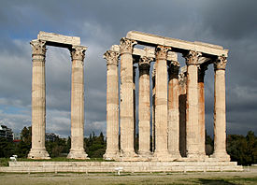
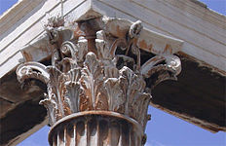
The tall capital combines both semi-naturalistic leaves and highly stylised tendrils forming volutes.

Corinthian Order
The Corinthian Order does not have its origin in wooden architecture. It grew directly out of the Ionic in the mid 5th century BC, and was initially of much the same style and proportion, but distinguished by its more ornate capitals. The capital was very much deeper than either the Doric or the Ionic capital, being shaped like a large krater, a bell-shaped mixing bowl, and being ornamented with a double row of acanthus leaves above which rose voluted tendrils, supporting the corners of the abacus, which, no longer perfectly square, splayed above them. According to Vitruvius, the capital was invented by a bronze founder, Callimarchus of Corinth, who took his inspiration from a basket of offerings that had been placed on a grave, with a flat tile on top to protect the goods. The basket had been placed on the root of an acanthus plant which had grown up around it.[ The ratio of the column height to diameter is generally 10:1, with the capital taking up more than 1/10 of the height. The ratio of capital height to diameter is generally about 1.16:1.]
The Corinthian Order was initially used internally, as at the Temple of Apollo Epicurius at Basae (c.450-425 BC). In 334 BC it appeared as an external feature on the Choragic Monument of Lysicrates in Athens, and then on a huge scale at the Temple of Zeus Olympia in Athens, (174 BC - AD 132).] It was popularised by the Romans, who added a number of refinements and decorative details. During the Hellenistic period, Corinthian columns were sometimes built without fluting.[

