Module III
WATER AND ITS TREATMENT
- What are the physical properties of pure water?
- Colourless, odourless and tasteless
- pH is 7
- Gives a bluish tinge in thick layers
- Freezes at 0⁰C and boils at 100⁰C
- Density is 1 g/cm³
- Water is polar and polar compounds dissolve in water
- Pure water is a poor conductor of electricity
- Define soft water and hard water
Water which produces lather readily with soap is called Soft water. Water which does not produce lather readily with soap is Hard water
- Give the reason for hardness of water.
It is due to the presence of bicarbonates (HCO₃²⁻), Chlorides (Cl⁻) or Sulphates (SO₄²⁻) of Calcium and Magnesium.
- Distinguish between soft and hard water
Soft water | Hard water
Gives lather readily with soap | Does not give lather readily with soap
Does not form insoluble scum with soap | Forms insoluble scum with soap
Does not contain dissolved impurities like Calcium/Magnesium salts | Contains dissolved bicarbonates, chlorides or sulphates of Ca and Mg
Advantages  - Suitable for cooking purposes  - Suitable for bathing  - Suitable for Laundry purpose  - Used in dyeing of textiles  - Used in boilers | Advantages  - Contains Ca/Mg ions required for health  - Does not dissolve lead from lead pipes in water supply system
Disadvantages  - It dissolves lead from lead pipes in water supply system leading to lead poisoning  - Does not contain dissolved salts of Ca and Mg required for health | Disadvantages  - Pulses do not cook well  - Wastage of domestic fuel  - Wastage of soap in laundry  - Wastage of fuel in boiler due to formation of scales in boilers  - Spots and damage in cloth  - Reduces cleaning quality of soap  - Drinking may lead to formation of Calcium Oxalate as stones in kidney/urinary tracts  - Danger of explosion in boiler due to crack of boiler scales and production of excess steam  - Corrosion of boiler due to generation of HCl from chlorides

- Why hard water does not form lather readily with soap?
Soaps are sodium salts of fatty acids (R-COONa). When soap is added to hard water, calcium or magnesium ions present in hard water will react with soap and form their insoluble salts. Hence lather is not formed. Lather will be formed only after all the dissolved impurities are precipitated
- What is temporary hardness of water? How will you remove it?
Temporary hardness is due to the presence of dissolved bicarbonates of Calcium and Magnesium.
Methods of removal
- Boiling- When boiled, the dissolved bicarbonates decompose and become insoluble carbonates. The precipitated carbonates are removed by filtration.
Ca(HCO₃)₂ → CaCO₃ ↓ + H₂O + CO₂ ↑
- Clarke’s process- Required quantity of slaked lime [Ca(OH)₂] is added to hard water to convert bicarbonates to carbonates and removed by filtration.
Ca(HCO₃)₂ + Ca(OH)₂ → 2CaCO₃ ↓ + 2H₂O
- What is permanent hardness of water? How will you remove it?
Permanent hardness is caused by the presence of chlorides and sulphates of Ca or Mg. This can be removed by Ion Exchange Method.
Hard water is first passed through a chamber with a bed of Cation Exchanger (E-H) capable of removing all positive ions (cations) by exchange with H⁺ ions.
2 E-H + Ca²⁺ → E₂Ca + 2H⁺
The water coming out of cation exchanger is then passed through a second tank containing an anion exchanger (E-OH) to remove all anions by an exchange with OH⁻ ions.
E- OH + Cl⁻ → E-Cl + OH⁻
The H+ and OH- formed combine to give water.
H⁺ + OH⁻ → H₂O
Regeneration of ion exchanger- Cation exchanger is regenerated by using an acid and Anion exchanger is regenerated by using an alkali solution.
- Define potable water. Give its characteristics.
Potable water is water which is safe to drink.
Characteristics
- It should be clear and odourless
- It should be pleasant to taste
- Its pH should be around 8
- It should be soft
- It should be free from all suspended impurities
- It should be free from objectionable dissolved gases like H₂S, CO₂, NH₃, etc.
- It should be free from all disease-causing microorganisms (pathogens).

- Explain the purification of water.
Purification is the treatment process to make potable water. It involves the following steps.
- Screening- Raw water is passed through mesh screens to remove gravel, debris, waste, etc.
- Sedimentation- Water is allowed to stand undisturbed for 6 to 12 hours. Suspended impurities will settle down.
- Coagulation- Fine impurities are made to settle down by adding coagulants like alum.
- Filtration- Colloidal impurities are removed by means of filters.

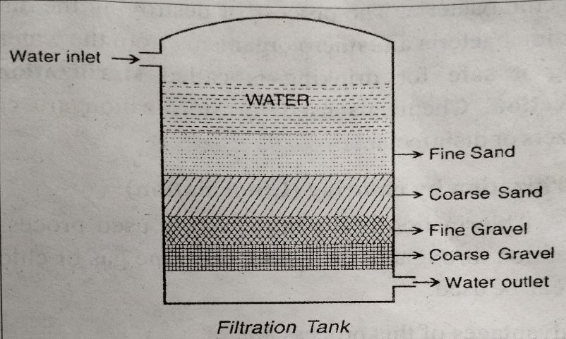

- Sterilisation- It is the process of destroying the disease producing microorganisms from water to make it safe for drinking.
- Sterilisation by Ozone- Ozone gas (O₃) is passed through water. Ozone splits immediately into oxygen gas and nascent oxygen.
O₃ → O₂ + [O]
This nascent oxygen is very effective in killing all germs and bacteria.
- Sterilisation by Chlorine- Water is disinfected using chlorine gas by allowing the gas to pass through the tank
Cl₂ + H₂O → HOCl + HCl
HOCl → HCl + [O]
The nascent oxygen formed will destroy pathogens.
- Sterilisation by Bleaching powder- Calculated amount of bleaching powder (CaOCl₂) is added to water and allowed to remain undisturbed for a few hours.
CaOCl₂ + H₂O → Ca(OH)₂ + Cl₂
Cl₂ + H₂O → HOCl + HCl
HOCl → HCl + [O]
The nascent oxygen formed will destroy pathogens.
- Sterilisation by UV radiation- UV light from a source is passed through water which kills all pathogens.
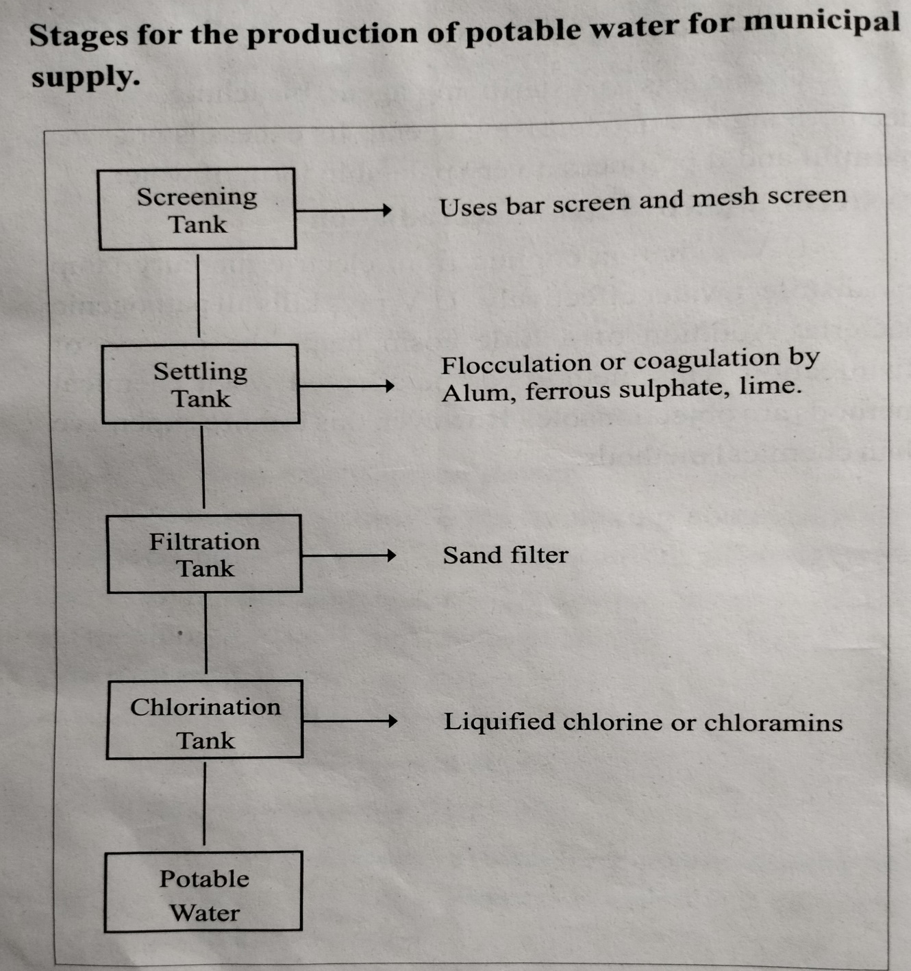
- Explain the process of desalination of sea water by reverse osmosis.
When two solutions with different concentrations are separated by a semi-permeable membrane (SPM), the solvent flows from dilute solution to the concentrated solution through the SPM. This is called Osmosis. When an external pressure equal to the osmotic pressure is applied over concentrated solution side, osmosis will be stopped. When a hydrostatic pressure greater than osmotic pressure is applied on the concentrated solution, the solvent will be forced to move from concentrated solution to dilute solution across the SPM. This is called reverse osmosis (RO). Thus, pure water can be separated from sea water using RO method.

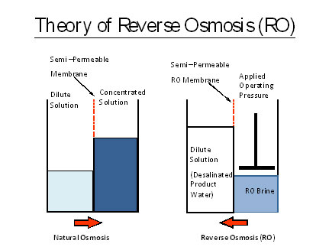

Advantages
- Removes ionic, non-ionic, colloidal and heavy organic impurities
- Removes colloidal silica.
- Capital cost required is less.
- Since the membrane can be replaced easily and immediately, the water supply is almost continuous.

