Binocular Vision
Binocular" is to see with both eyes simultaneously.
"Stereoscopic" is to see things as 3-dimensional.

In human
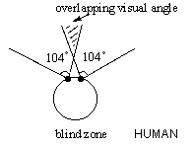
Each eye has a fixed visual angle. In our eye, the angle is 104°. Since our two eyes are placed close together, overlapping of visual angles results. This allows more accurate judgement of distance of the object in front of us.
To see 3D, when our 2 eyes focus on one object, slightly different images from both eyes are sent to the brain, where the impulses will be fused to compose a single image. If our extrinsic eye muscles cannot function well or when we are under the influence of alcohol, double vision, i.e. diplopia would occur.
Try double vision: Look at a near object. Press one of your eyes slightly. You'll see two separate images.

In other animals
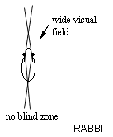
Good binocular & stereoscopic vision is important for animals who are predators, e.g. hawks and lions. They have to accurately judge the distance to catch prey. Their eyes are set in front.
Other animals, e.g. a rabbit (a common prey), has an eye on each of the two sides of its head. It has a wide overall visual field, which is good for detecting movements. But little overlapping of visual field results in poor stereoscopic vision.
The animals with eyes on the sides of their head rely on 1)the relative size of an object, 2)the shadow it creates, 3)the movement of it relative to distant non-moving objects, to judge distance.

Olfactory and optical shift
Due to their arboreal life primates have an increased reliance on vision and a decreased reliance on olfaction (smell).
Other mammals and the more primitive, arboreal primates have a sensitive snout and a well-developed sense of smell. It is suggested that this compensates for their poor vision.
Most mammals have eyes positioned on the side of their heads.
With side-facing eyes, not only is their vision restricted to two-dimensional – with information being processed from one eye at a time (monocular vision) – but it's believed that the retinas of their eyes only possess one type of receptor that detected low wavelengths of light. This meant they could only see in low-light conditions – a factor which also led them to being nocturnal animals.
The primates with more forward-facing eyes held a strong advantage over their relatives with more side-facing eyes. The overlapping field of view (stereoscopic or binocular vision) allows for a three-dimensional view of the world.
For tree-dwelling primates the ability to judge distances when moving about in the treetops was a distinct advantage. It is also believed that having additional receptors capable of detecting a broader range of wavelengths of light meant these primates could see the world in colour. Binocular, colour vision resulted in animals with an ability to judge distances and to differentiate objects, food and potential danger more easily. While many primates still slept in trees, it's believed that many became daytime, ground-dwelling (terrestrial) animals.
Binocular vision provides an overlapping, three-dimensional field of view. Monocular vision provides a limited two-dimensional view.
The need for a keen sense of smell diminished as visual acuity improved. This trend can be seen by comparing the more primitive tree shrew brain to the macaque and human brains as shown below. Notice the size of the olfactory bulb.
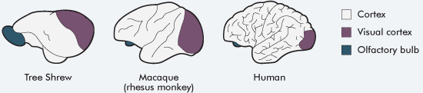
Reproduced with the permission of the Science Teachers Association of Western Australia Inc
Each of the three brains shows the olfactory bulb, cerebral cortex and the visual cortex.
- In the tree shrew, the largest area is the cortex but it has few folds. The visual cortex is the next largest area and the olfactory bulb is small, but larger than in the other two brains.
- The macaque's brain shows a smaller olfactory bulb, a visual cortex the same area as shown in the tree shrew and the cerebral cortex slightly larger than the tree shrew's but with more folds.
- The human brain has a small olfactory bulb and slightly smaller visual cortex compared to the other two brains, but a much larger cerebral cortex with many folds.

