WHAT IS AN OPTICAL FIBRE?
Optical fibre is the technology associated with data transmission using light pulses traveling along with a long fibre which is usually made of plastic or glass. Optical fibres are also unaffected by electromagnetic interference. The fibre optical cable uses the application of total internal reflection of light.
A Fibre Optic Relay System consists of the following components:
The Transmitter – It produces the light signals and encodes them to fit to transmit.(LASER)
The Optical Fibre – The medium for transmitting the light pulse (signal).
The Optical Receiver – It receives the transmitted light pulse (signal) and decodes them to be fit to use. PHOTO CELL)
The Optical Regenerator – Necessary for long distance data transmission. (
MAIN PARTS S OF OPTICAL FIBRE:
Core: It is the central tube of very thin size made of optically transparent dielectric medium and carries the light transmitter to receiver and the core diameter may vary from about 5um to 100 um.
Cladding: It is outer optical material surrounding the core having reflecting index lower than core . Cladding helps to keep the light within the core throughout the phenomena of total internal reflection.
Buffer Coating: It is a plastic coating that protects the fiber made of silicon rubber. The typical diameter of the fibre after the coating is 250-300 um
The jacket used in such POFs is polyethylene/PVC
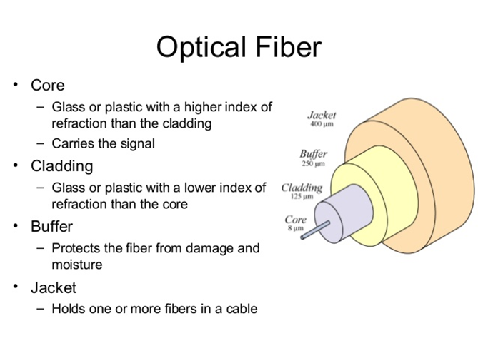
Classification On the basis of the Number of Modes:
(a). Single-mode fibre: A single mode fibre is used for long-distance transmission. In single-mode fibre, only one type of ray of light can propagate through the fibre. This type of fibre has a small core diameter (5um) and high cladding diameter (70um) and the difference between the refractive index of core and cladding is very small. There is no dispersion i.e. no degradation of the signal during traveling through the fibre.
(b). Multi-mode fibre: Multimode fibre is used for shorter distances. Multimode fibre allows a large number of modes for the light ray traveling through it. The core diameter is generally (40um) and that of cladding is (70um). The relative refractive index difference is also greater than single mode fibre. There is signal degradation due to multimode dispersion. It is not suitable for long-distance communication due to large dispersion and attenuation of the signal. . POFs are primarily available as multimode fibers.

PLASTIC OPTICAL FIBRE (POF)
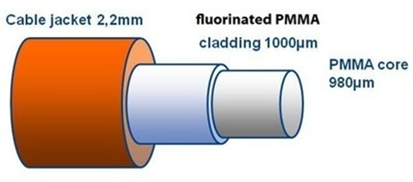
The working principal of plastic optical fibres is based on the phenomenon of total internal reflection (a material can reflect light within an optical waveguide, i.e. when a light pass through the material surrounded by other materials with lower refractive indices, then light reflected inside the medium) On this basis, a common optical fibre consists of a highly transparent core with a high refractive index (PMMA) and a surrounding cladding with a low RI (FLUROPOLYMERS) . POFs are primarily available as multimode fibers.
Refractive index is the ratio of the velocity of light of a specified wavelength in the air to its velocity in the examined substance. When this principle of measurement is used it may be defined as the sine of the angle of incidence divided by the sine of the angle of refraction. Low refractive index plastics are extremely useful for optical applications such as optical fibre cladding Eg-(PTFE1.3). High refractive index plastics are extremely useful for optical applications such as, for optical fibre CORE eg-PMMA,PS,PC(1.5-1.6) .Optical fibres where the RI changes in discrete steps are called step-index
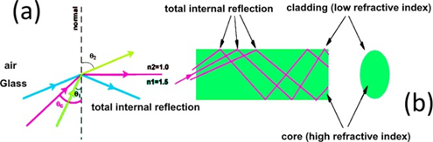

A variety of optical polymers(transperent amorphous polymers) are used in the fabrication of POFs, including polymethyl-methacrylate (PMMA), amorphous fluorinated polymer ,polystyrene (PS), and polycarbonate .
MANUFACTURIG OF POF
There are basically two distinct methods used for polymeric optical fibre manufacture:
1 Fibre drawing from the preform,
2 The extrusion method.
1 PREFORM MAKING AND FIBRE DRAWING FROM THE PREFORM
It consists of three different steps- purification of initial materials, fabrication of the preform with the desired refractive index profile, and finally fibre drawing
A .Purification of initial materials,
Due to purity demands, the preferred method for synthesising polymer material for optical fibres is bulk polymerisation. To avoid the reduction of the transmission properties of POF, polymerisation catalysts, the monomers and other additives should by purified by distillation, filtration with a membrane filter
B .Fabrication of the preform with the desired refractive index profile
The essence of the CVD-process is that a reaction mixture as a vapour is fed into a rotating tube fixed in a horizontal position. In the beginning, the mixture contains more compounds with low RI, and in the end it contains more with high RI. If necessary, each layer is polymerised up to a certain conversion, and then the next is applied
C. fibre drawing
After making a preform, it is drawn at 190-2300C using furnace. An essential moment is the tension of the fibre during the spinning process. It must be within 50-100g
2 EXTRUSION methods
The extrusion of POF (SI) can be performed by a co-extrusion of multi-layered fibre. The co-extrusion of POF can be achieved by concentrically multi-arranging two or three extrusion nozzles whose injection ports are sequentially located from the upstream side to the downstream side. The RI profile is built up step-by-step. From the upmost nozzle emerges the cylinder of the first melt transparent polymer (core). From the next nozzle a melt mixture of polymer and/or diffusible nonpolymerising additives with a RI different from the first polymer is injected into the central part of cylinder (cladding).

MANUFACTURING PLASTIC OPTICAL FIBER USING PC AS CORE MATERIAL
The plastic optical fiber using PC as the core material has a heat resistance of 120 °C or higher which is 30 °C or so higher than that of the plastic optical fiber using PMMA as the core material. PC polymer is dissolved in an organic solvent containing methylene chloride, and unreacted substances and by-products are removed from the solvent solution by washing. The polymer is recovered by removing the solvent using a spray drying method. Then directly carry out the melt spinning of polymer recovered from the polymerization process without pelletizing it to produce a plastic optical fiber with high transmissibility. It is also necessary to inhibit crystallization of polymer during the melt spinning.
ADVANDAGES AND APPLICATION OF POF
-Plastic optical fibres (POF) are often used in telecommunication, consumer electronics and automotive applications, medical and military and mining applications. In telecommunication it used for LAN (local area network transmissions) like inside campus ,bank, hospital. It can transfer data rates up to 800Mbps. POFs which offer high bandwidth, total electromagnetic immunity and simple handling are considered as an alternative to noisy copper cables and high performance glass optic fibres Plastic optical fibres have simpler and less expensive components, as well as greater flexibility, and resiliency to bending, low shock and vibration. In addition, they are lighter in weight. Easy to installations and reworks over glass OFC POF has excellent compatibility with organic materials, which gives them great potential for biomedical sensor applications. Mainly used in endoscopy and in keyhole surgeries

