Corrugated Sheet a thin structural sheet made of iron or steel, formed with alternating ridges and troughs.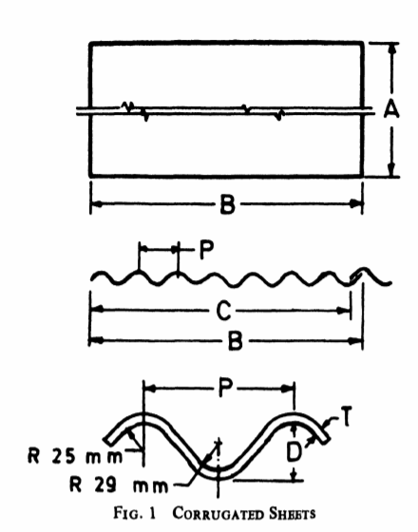
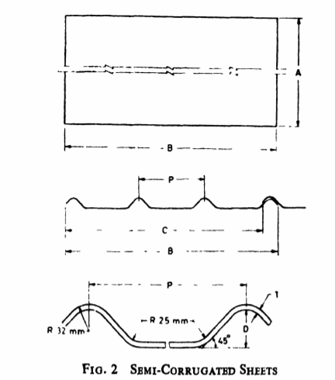
VALLEY GUTTER : Water from a pitched roof flows down into a valley gutter.
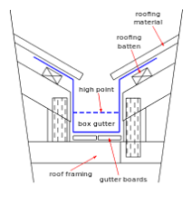
BOUNDARY WALL GUTTER :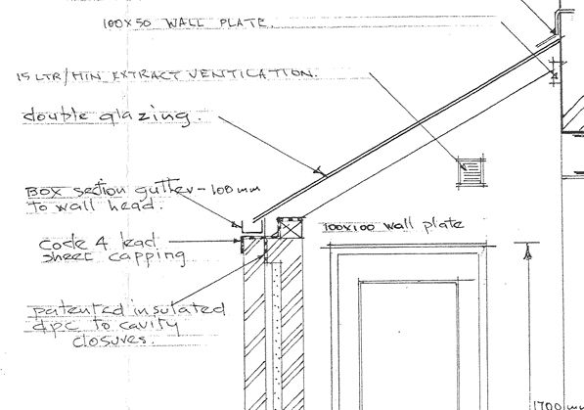
NORTH LIGHT CURVE : North Light Curves are widely used to obstruct direct sun rays and rainfall or for covering openings in shed.

