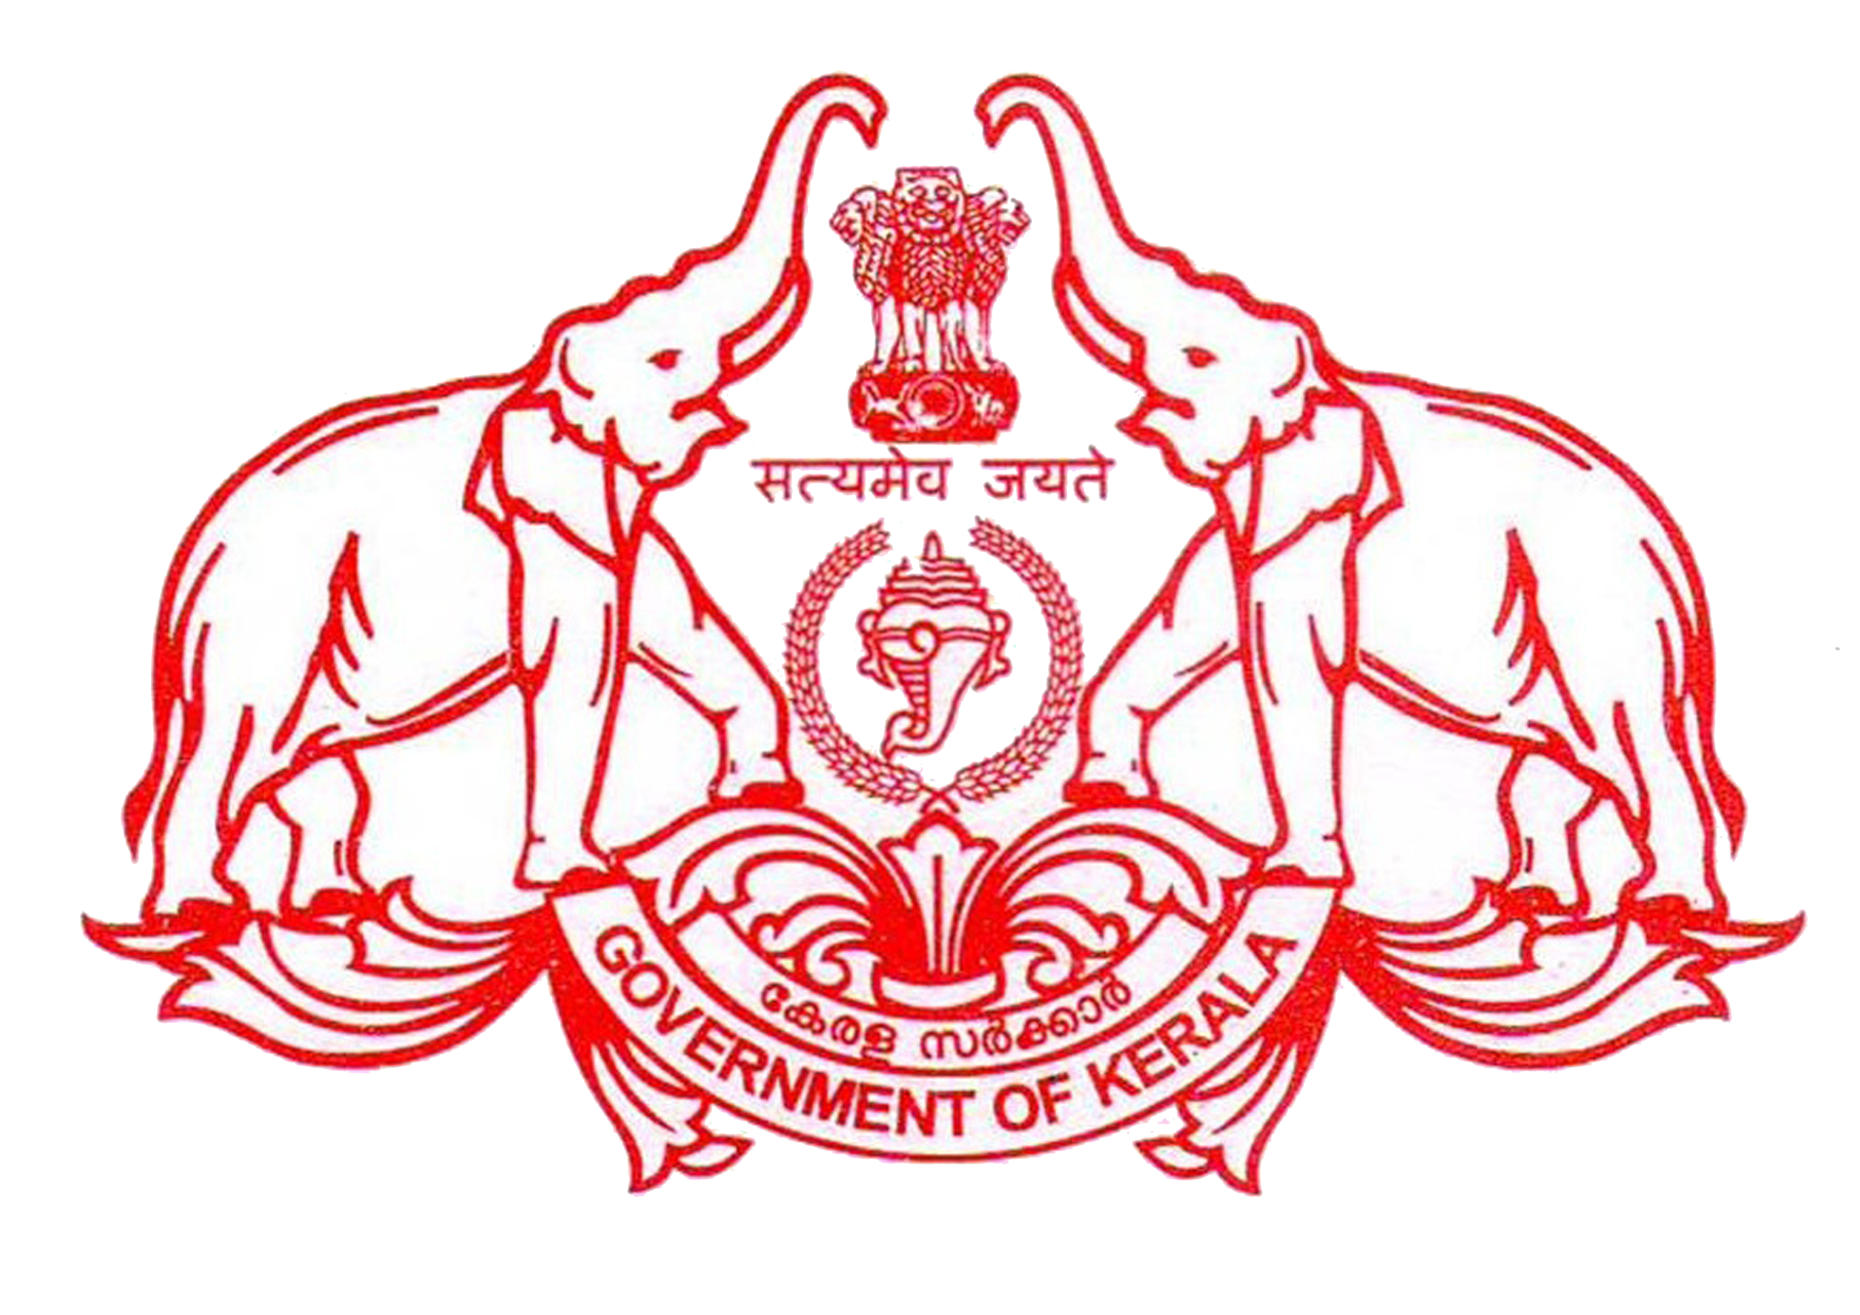
STATE INSTITUTE OF TECHNICAL TEACHERS TRAINING & RESEARCH
[Curriculum Development Centre renamed as per G.O.(MS) No: 604/2014/H.Edn]
Department of Technical Education, Govt. of Kerala
HMT Junction, Kalamassery, Kochi – 683 104
E-mail:sitttr@gmail.com, jd_cdc@yahoo.com
Phone & Fax: 0484 2542355 Website: www.sitttrkerala.ac.in
No. SITTTR/1320/2016 Dated: 27/06/2016

Circular
Sub: Discussion during Academic Planning of Principals of Polytechnic Colleges held at Wayanad- Reg.
Principals of all Govt. And Aided Polytechnic Colleges are directed to take necessary action regarding the following points after convening a meeting of all faculty and staff:
- Steps to provide English newspapers to all class rooms by meeting expenditure from sponsors, student associations or PTA.
- Steps to conduct quiz programmes atleast once in every month based on current issues - class wise or department wise.
- Form quality Circle to review and plan academic activities and meet on every Friday. Form a committee of Principals, HOD’s and workshop superintendent at higher level and a sub committee of HOD’s , Lecturers, Demonstrators, Trade Instructors and Tradesman.
- Arrange centralized PA system to conduct GK and English programmes – in break hours.
- Steps to place vocabulary boards in each Department in the institution. The class tutor will be in-charge of General Knowledge and communication skills.
- Form English clubs under the supervision of English teacher or any faculty interested in that. Good speakers should be invited.
- Implement mentor system 10: 1 in all polytechnic colleges, in all semester Clasess, Conduct PTA meetings compulsorily atleast twice a semester.

Sd/-
Joint Director

