LINGARAAJA TEMPLE
LOCATION: Bhubaneswar , Orissa
Lingaraaja is a temple of the Hindu god Shiva and is one of the oldest temples in Bhubaneswar.
The temple of Lingaraja, the biggest of all at Bhubaneswar is located within a spacious compound wall of latte rite measuring 520 feet by 465 feet.
The wall is 7 feet 6 inches thick and surmounted by a plain slant coping.
Rising to a height of about one hundred and eighty feet and dominating the entire landscape it represents the quintessence of the Kalinga type of architecture and the culminating result of the architectural tradition at Bhubaneswar.
Lingaraaj means 'the king of Lingas', 'Linga' being the symbol of Lord Shiva worship.
The temple is more than 1000 years old, dating back in its present form to the last decade of the eleventh century
The temple is traditionally believed, though without historical authentication, to be built by the Somavanshi king Jajati Keshari, in 11th century AD.
Jajati Keshari had shifted his capital from Jajpur to Bhubaneswar which was referred to as Ekamra Kshetra in the Brahma Purana, an ancient scripture.
This temple has actually four parts: the main temple, the Yajna Shala, the Bhoga Mandap and finally the Natya Shala.
This temple has images of both Shiva and Vishnu.
Vishnu is actually present as Shaligram idol. The Shiva idol are surrounding the Vishnu (Shaligram) idol.
The Shiva idol are surrounding the Vishnu (Shaligram) idol. Even the temple on the top has got no trishula (trident - the weapon of Shiva) and even Chakra (discus - weapon of Lord Vishnu). It has only Lord Rama's arrow symbol, probably because Lord Rama was a worshipper of Lord Shiva.
The temple's main gates have images of Lord Shiva, Trishula on one side and Lord Vishnu, Chakra on the other side.
This magnificent temple, dedicated to Shiva, represents the type of Hindu architecture
ARCHITECTURE: The remarkable structure of the temple gives the tint of Kalinga style of architecture. The aesthetic sculptures look at their apex in this architectural exhibition. Erected in red sandstone, Lingraj Temple has the stone of the darkest shade. The huge temple complex covers the vast lands of Bhubaneswar in a stretch. The tall spire of the temple extends to the height of 55 meters and literally, dominates the skyline of Bhubaneshwar. The spacious courtyard comprises 50 small shrines that are dedicated to several Gods of Hindu.
SUN TEMPLE - KONARK
The Konark Sun Temple is a 13th century Sun Temple (also known as the black pagoda) at Konark, in Orissa.
It was constructed from oxidizing and weathered ferruginous sandstone by King Narasimhadeva
(1236-1264 CE)
The temple takes the form of Surya(Arka),the sun god and is heavily decorated with stone carving.The entire complex was desgined in the form of a huge chariot drawn by seven spirited horses on twelve pairs of exquisitely decorated wheels.
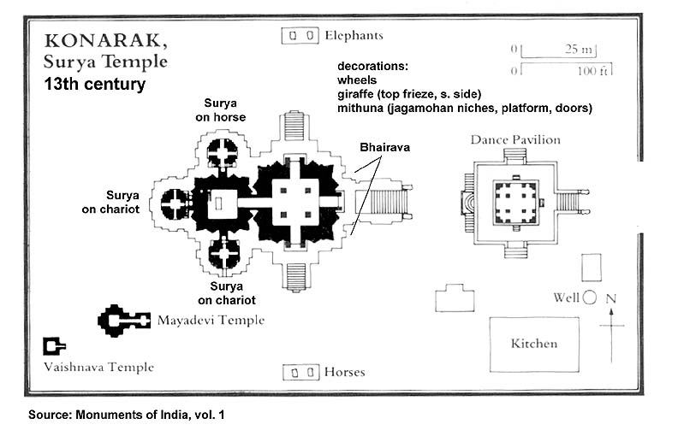
The temple symbolizes the majestic stride of the Sun god.
At the entrance of the temple is the nata mandir.
NATA MANDIR is a place where the temple dancers used to perform dances in homage to the Sun god.
Every inch of the the temple is covered with sculpture of an unsurpassed beauty and grace in tableaux and freestanding ranging from the monumental to the miniature.
There are images of deities , celestial and human musicians, dancers, lovers and myriad scenes of courtly life. These are interspersed with birds , animals , mythological creatures etc.
Papanatha Temple
Papanatha Temple is the only temple that has been designed on both north and south Indian styles of architecture. Containing a Nagara styled Vimanam, the temple dates back to 680 AD. Initially, the construction was started with Nagara style, but later it was switched to Dravidian style. The temple is famous for its sculptures that are imbibed from the scenes of Ramayana and Mahabharata.
Dedicated to Mukteswara according to inscriptions, this modest temple seems to have been completed around 740 A.D. There seems to have been a change of intention during the course of construction of this temple as can be known from its too narrow circumambulatory path whose floor slabs conceal the external moulding of the garbhagriha walls and the buttress like projections of the north and south garbhagriha-walls into the ardha-mandapa, both of which are unusual features.
Facing the east, this temple has on plan a sanctum (garbhagriha ) surrounded by a circumambulatory path (pradakshinapatha) with devakoshtha pavilions in its three walls, an ardha-mandpa, a sabha-mandapa and an entrance porch (mukhamandapa) provided with kakshasana. Curiously, there is no Nandi-mandapa but an ornate image of Nandi is housed in the eastern half of the sabha-mandapa.
The temple is built on a plinth of five mouldings, embellished with animal motifs, floral designs and kudus. The wall surfaces are relieved with niches (devakoshthas) housing Saiva and Vaishnava deities and depicting episodes from the Ramayana. These niches are topped by various designs of chaitya-arch motifs and interspersed with perforated windows. The three devakoshtha pavilions house images of Siva in different forms. A characteristic feature of the temple is its well-developed rekha-nagara (northern) sikhara with an elaborately carved Chaitya-arch enshrining Nataraja on the frontage of the sukanasa. The amalaka and kalasa are, however, missing.
Introduction of narrative panels depicting the episodes from the Kiratarjuniya and the Ramayana on the outer wall surfaces isanother noteworthy feature of the temple. Significantly, names of the main characters of the episodes as also those of the sculptures like Baladeva, Devaraya, Changama, Revadi, Ovajja, etc., are found engraved in right places.
Pillars of the entrance porch bear Kinnara couples and engaged columns have the figures of Dvarapalas. Lions and sardulas are carved at the corners above the entablature and the ceiling panel depicts dancing Siva with Parvati and musicians and flying figures. Pillars and pilasters of the other mandapas are relieved with medium-sized graceful sculptures of damsels and couples (mithunas) in playful moods. The central bay ceiling of the sabha-mandapa is adorned with panels depicting Anantasayana surrounded by the Dikpalas, nagaraja and Gajalakshmi from east to west. Here figures of rearing lions are cared projecting from above the entablature. Central ceiling of the ardha-mandapa has relief sculpture of dancing Siva in the company of Parvati and musicians. The western ceiling here has figure of Nagaraja. Both the mandapas and the sanctum have ornate doorframes.

