Unit III Recycling & reuse
Architectural reuse – waste prevention, pre building, building, post building stages, construction and demolition recycling -Conservation of natural and building resources – types of wastes – elimination of waste and minimize of pollution – various decomposing methods –Case Studies: Sustainable Development Case Studies: illustrated examples of the planning, development, and construction.

Adaptive reuse
- Refers to the process of reusing an old site or building for a purpose other than which it was built or designed for.

Factors affecting adaptive reuse
- societal value of a given site
- potential for the reuse of a particular site;
- historical importance of the site - terms of both the physicality of the street-scape and the area
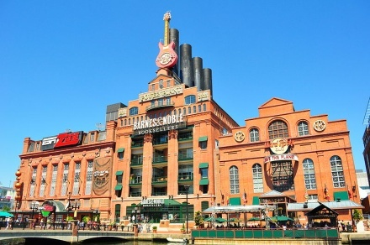
- natural ecological conditions of the site

Pratt Street Power Plant in Baltimore, Maryland, United States, converted into retail, restaurants, and offices.

Rock Garden of Chandigarh
it is spread over an area of forty-acres,
it is completely built of industrial & home waste and thrown-away items.
man-made interlinked waterfalls and many other sculptures that have been made of scrap & other kinds of wastes (bottles, glasses, bangles, tiles, ceramic pots, sinks, electrical waste, etc.) which are placed in walledpaths), complex of interlinked courtyards, each filled with hundreds of pottery-covered concrete sculptures of dancers, musicians, and animals

“Waste - a resource in the wrong place"
-- An old Chinese proverb
Waste – Noun Vs Verb
waste v. | waste n.
1. to use, consume, spend, or expend thoughtlessly or carelessly | 1. a place, region, or land that is uninhabited or uncultivated
2. to cause to lose energy, strength, or vigor; exhaust, tire, or enfeeble | 2. a devasted or destroyed region, town, or building; a ruin
3. to fail to take advantage of or use for profit | 3. a useless or worthless by-product, as from a manufacturing process
4. to destroy completely | 4. garbage; trash

Waste prevention ……right form
Planning Process | Site selection and planning  Budget planning  Capital planning  Programme planning
Design Process | Client awareness and goal setting - Green vision, project goals & green design criteria  Team development  Well-integrated design  Resource management  Performance goals
Operation & Maintenance | Commissioning of building systems  Building operation  Maintenance practices  Renovation & demolition

Construction Waste Management
- Responsible management of waste is an essential aspect of sustainable building.
- sustainable management of resources - reduction, recycling, and reuse of wastes
- In this context, managing waste means
  - eliminating waste where possible;
  - minimizing waste where feasible; and
  - Reusing materials which might otherwise become waste.

Effective management of building-related waste
- Waste prevention
- Recycling construction and demolition materials
- Architectural reuse (include adaptive reuse, conservative disassembly, and reusing salvaged materials)
- Design for material recovery (durability, disassembly, adaptive reuse)

Waste prevention is about the way in which the products and services we all rely on are
- designed
- Made
- bought
- sold
- Used
- Consumed
- disposed

Jobsite Sorting | - efficient identification and sorting of materials is an important factor  - Materials may be sorted into a number of containers provided by service companies that specialize in management of specific types of waste at the jobsite.  - least number of containers is desirable both to keep container volumes high to reduce transportation trips and costs
Collection and Hauling | Containers containing construction and demolition waste are collected and transported to diversion facilities via truck.
Tipping | Identification of loads on arrival at construction and demolition debris diversion facilities is an important step in ensuring materials are appropriately handled.
Picking | Materials such as steel reinforcing bar, carpeting, large pieces of wood, concrete and materials with dimensions greater than 3 feet are usually picked before the sorting process can begin in earnest.
Sorting | involves loading materials onto an inclined metal belt—a chainbelt—and passed across a manual sortline consisting of a flexible rubber belt and integral sort stations providing a place for several workers to stand, usually opposite from one another down the length of the belt.  Materials are identified, grabbed, and deposited in vertical openings at each sort station.
Containerization and Transport | Picked and sorted materials are deposited by means of equipment and manual labor into industrial containers of various types.  Heavy interstate trucks are an important part of the transportation system.  Containers of all types are destined for transport locally, regionally, nationally and internationally.
Diversion or Disposal | incorporation in new products as recycled material, or are processed for reuse. Materials destined for disposal in landfills include refuse, materials contaminated with waste or which have been ruined, and materials for which markets do not exist.

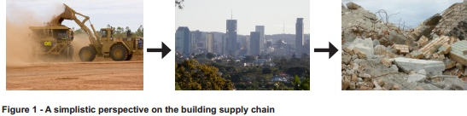
Construction & demolition recycling
- Building materials account for about half of all materials used and about half the solid waste generated worldwide.
- They have an environmental impact at every step of the building process—
- Extraction of raw materials
- processing
- Manufacturing
- Transportation
- Construction
- Disposal at the end of a building’s useful life.

Construction and demolition waste
- Construction and demolition (C&D) waste is a general term for a diverse range of materials that, when segregated, can include high-value materials and resources for new construction.
- Construction and demolition waste is generated whenever any construction/demolition activity takes place, such as, building roads, bridges, fly over, subway etc.
- Consists mostly of inert and non-biodegradable material such as concrete, plaster, metal, wood, plastics etc.

Advantages and Disadvantages of Source Separation vs Commingled Recycling
Recycling Method | Advantages | Disadvantages
Source Separation - separating different recyclable materials at the job site | • Higher recycling rates  • Lower recycling costs; revenues paid for some materials  • Often a cleaner, safer work site | • Multiple containers on site  • Workers must separate  materials for recycling  • More complex logistics  • Multiple markets; more  information to manage
Commingled  Recycling-means placing all recyclable materials into a single container, which is then transported to a processing facility, where different materials are separated by hand or by automated equipment. | Only one or two containers on site  • No need for workers to separate materials for recycling  • Easier logistics  • One market; less information to manage | • Lower recycling rates  • Higher recycling costs

Source separation
- is more complex because workers must separate waste materials before they throw them away
- there are more containers on site
- There are more markets and haulers to work with and keep track of.

Source separation is economically more advantageous than commingled recycling
- Source separation produces materials that are ready to go directly to market;
- There is no need to pay a processor to sort materials.
• Source separated materials are generally of higher quality, with fewer contaminants
- They’re worth more in recycling markets

A few additional rules make source separation work smoothly
- Keep as few containers as possible on site at any time.
- Match containers to the material.
- Place containers close to work locations

WHAT TO LOOK FOR IN A HAULER FOR RECYCLED MATERIALS

Flexibility | - Different types of containers and vehicles for different recycled materials?  - Number of trucks and containers  - Meet the client’s requirements  - Response time
Market Relationships | Are they tied to only one or a few markets, or do they work with many markets? Will they work with markets that you identify?
Reliability | - Check with other people they’ve worked with. Do they show up on time, and call if there are going to be any problems?  - Do they have backup if a truck or another piece of equipment breaks down?
Location | Where are they located compared to the job site and to markets? Longer hauls mean more cost and more possibilities for things to go wrong?
Cost | What is their price structure? Be sure to comparison shop, because proposed rates can  Vary by 30% or 40% for the same haul.
Safety | Ask for documentation of safety and driving violations

WHAT TO LOOK FOR IN A MARKET FOR A RECYCLED MATERIAL(S

Process and End Products | Be sure you’re comfortable that their recycling process and products are in line with your own recycling and environmental goals.
Materials | How many do they handle? All other things being equal, you’d prefer to deal with fewer markets. Be sure to shop and compare
Hauling | Will they haul as well as provide a market?
Pricing | How do they compare to other markets for the same materials?  Do they return revenues for materials like metals? Are prices tied to published indexes?
Financial History | Check credit references and other sources of information to verify stability
Tracking/Reporting | Certificates of recycling, or other documentation you need to confirm recycling quantities, rates, and ultimate end uses.
Safety and Environmental Record | Do an on-site audit. Look for safety and environmental issues  (Availability of safety equipment, general neatness, attitudes toward safety/environment, etc.)
Insurance | Confirm that insurance is in place, adequate, and paid up.

Building Materials – Major components
- Cement concrete
- Bricks
- Cement plaster
- Steel (from RCC, door/window frames, roofing support, railings of staircase etc.)
- Rubble
- Stone (marble, granite, sand stone)
- Timber/wood (especially demolition of old buildings)

Building Materials – Minor components
- Conduits (iron, plastic)
- Pipes (GI, iron, plastic)
- Electrical fixtures (copper/aluminium wiring, wooden baton
- bakelite/plastic switches, wire insulation)
- Panels (wooden, laminated)
- Others (glazed tiles, glass panes)

STORAGE OF CONSTRUCTION AND DEMOLITION WASTE
- should be stored within the site
- keep the waste segregated into different heaps , further gradation and reuse is facilitated
- Segregation – reused in the site, sold / refilled
- Local body should provide required containers
- Public projects –special provision for storage of wastes

COLLECTION AND TRANSPORTATION
- Skipp lifters, trailers, tractors (manual loading and unloading – last option)
- For small generators of construction debris, e.g., petty repair/maintenance job, there may be two options –
(i) specific places for such dumping by the local body
(ii) removal on payment basis.

RECYCLING AND REUSE
- Reuse (at site) of bricks, stone slabs, timber, conduits, piping railings etc. to the extent possible and depending upon their condition.
- Sale / auction of material which cannot be used at the site due to design constraint or change in design.
- Plastics, broken glass, scrap metal etc. can be used by recycling industries.
- Rubble, brick bats, broken plaster/concrete pieces etc. can be used for
Building activity, such as, leveling, under coat of lanes where the traffic does not constitute of heavy moving loads.
- Larger unusable pieces can be sent for filling up low-lying areas.
- Fine material, such as, sand, dust etc. can be used as cover material over
Sanitary landfill.

INSTITUTIONAL AND REGULATORY ASPECTS – FOUR OPTIONS
- The total activity may be contracted out.
- Only vehicles may be leased out by the civic body to the private contractor for transport of debris with his own labour, i.e., labour contract.
- The vehicles may be hired by the local body from private sources for transport of debris with municipal labour.
- The total activity may be carried out by the LOCAL BODY.

Material | Description and Sources | Markets | Limitations on Recycling
Brick | Largely from demolition and renovation.  Limited waste from new construction. | High-value re-use markets for some brick.  Used in aggregate production. | Few limitations.
Concrete, Formed | Largely from demolition and renovation.  Limited waste from new construction. | Mixed aggregate markets with brick and block.  Used in aggregate production. | Concrete w/ rebar typically must be  separated from brick, block, and  concrete w/out rebar.
Concrete Block | Largely from demolition and renovation.  Limited waste from new construction. | Mixed aggregate markets with brick and concrete. | Few limitations.
Metals, Ferrous | Structural and framing steel from demolition. Framing scrap from new  construction and renovation. | Scrap markets; used in production of new steel. | Few limitations.
Metals, NonFerrous | Aluminum, copper, brass and alloys from electric, plumbing, and HVAC.  Often significant scrap in new construction. | Scrap markets. Highest value if separated by metal at point of  generation.  Can be mixed and  marketed with ferrous metals. | Few limitations.
Wood, Engineered | Significant quantities from new construction and renovation as well as  demolition. | Some re-use value through  deconstruction. Most is recycled as  boiler fuel. | Generally few limitations.
Gypsum Wallboard | Clean scrap from renovation and new  construction. | Currently no markets for demolition wallboard. | Clean scrap from new installation only, without tape, nails, screws, corner  bead.
Ceiling Tiles | Largely from demolition and renovation.  Generally limited waste from new  construction. | Recyclable with considerable quantity | Subjected to test before recycling
Roofing, Metal | Large quantities from demolition and  renovation. | Scrap markets. | Few limitations.
Carpet | Large quantities from replacement, demolition, renovation. Significant scrap from new installation. | Carpet is  taken apart into multiple materials  which are then recycled separately | Carpet must be dry and mold free.  Cost is typically very high.
Mixed Debris | Large quantities from demolition and  renovation.  Small to large quantities from new construction, depending on  feasibility of source separation | Sorted mechanically and/or by hand  into constituents, typically wood, metal,  aggregate, and residual. | Recycling  rates typically less than source separated, and costs are typically  higher.

Wastes
- Garbage – from food
- Rubbish – non decomposable wastes or non combustible
- Ashes – residues of the combustion of solid fuels
- Large wastes – demolition & construction debris & trees
- Sewage treatment plants - material retained on sewage-treatment screens, settled solids, and biomass sludge
- Industrial wastes - such materials as chemicals, paints, and sand
- Mining wastes - slag heaps and coal refuse piles
- Agricultural wastes - farm animal manure and crop residues.
- Medical wastes - refers to waste products produced from healthcare premises, such as hospitals, clinics, doctor’s offices, veterinary hospitals and labs.

Wastes used in construction industry
- Industrial waste – fly ash bricks, fly ash, concrete, gypsum, blast furnace slag, phosphorous slag, lime slag, waste lime stone
- Agricultural waste – rice husk, rice husk ash, bamboo, wood residues, coconut waste
- Mining industry

INDUSTRIAL WASTES
- FLYASH BRICKS – 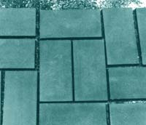
- Consist of silica, cobalt, alumina, magnesium, calcium, copper, radium, arsenic, radium, etc.
- Many projects and much experience in recent years, different option is available for utilization of fly ash.
- It can be used as raw materials in aerated light-weight cellular blocks and slabs, Clay bonded fly ash bricks/blocks, Sand lime fly ash bricks (Calcium silicate bricks), Precast fly ash concrete building elements/components, precast blocks for footpaths and fly ash ceramics.
- FLY ASH CONCRETE– 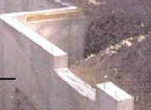
- Generated at coal-burning power plants.
- Used in landfills, but because of its physical properties it can be used in concrete as a replacement for cement.
- Substituting fly ash for at least 15-20% of the cement in concrete is common.
- Fly ash concrete usually costs the same as, or even less than, conventional concrete.
- Substituting fly ash for cement saves energy and avoids the carbon dioxide and other pollutants generated by making cement.
- Fly ash concrete takes longer to cure, but it provides a stronger concrete known for its smooth surface finish.

- GYPSUM- 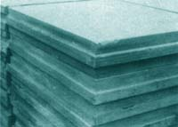
- It occurs naturally as well as it is an industrial byproduct
By-product Gypsum –
- High grade by product gypsum from ammonium phosphate and hydrofluoric and phosphoric acid industries continue to be discarded as wastes.
The range of products includes:
- Partition panels,
- Ceiling tiles/boards;
- Fibre reinforced or wood chip boards;
- walling blocks/bricks with/without fly ash
- Gypsum marble/slotted tiles; plaster boards;
- Processed gypsum can be used for special plasters and as ingredient in Fal-G cement and precast building elements.
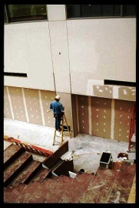
- BLAST FURNACE SLAG –
- For every ton of pig iron, 0.5 to 1.2 tones blast furnace slag is produced.
- This slag is considered an excellent aggregate for dense concrete and the cheapest among all well proven lightweight aggregates.
- Foamed slag must find greater application for structural lightweight concrete as well as masonry blocks.
- PHOSPHOROUS SLAG –
- By-product in the production of elemental phosphorous by electro-thermo process.
- This slag is used for the manufacture of slag cement.
- LIME SLUDGE & WASTE LIME STONE-
- Lime sludge is mixed with rice husk and waster and formed into balls or cakes, dried in the sun, burnt and ground to produce a self-setting cementing material.
- This cementing materials has been evaluated for its application in mortar and plaster work as well as in the manufacture of soil-stabilized bricks.
- LIME STONES –
- Lime stone rejects in the limestone quarries as well as under burnt lime rejects admixed with dust and ashes in lime kilns.
- Such materials can be ground along with small quantity of Portland cement or a little fresh lime to produce masonry cement or activated lime pozzolana mixture.

MINING & MINERAL WASTES
- In the mining and beneficiation of various minerals, such as ores of copper, silver, gold, zinc and iron, huge quantities of siliceous and dolomitic fine wastes are discharged.
- Some of these wastes contain very harmful minor constituents such as cyanides and arsenic compounds which constitute great danger of the pollution of nearby waste streams.
- Such solid waste could find use as part replacement of cement in the manufacture of pre-cast blocks, cellular concrete, sand lime bricks and concrete flooring tiles.
- Mining operation in the cutting and processing of slate, granites, limestone, dolomite, marble, laterite, etc. also produce small chippings mixed with lime or cement can be used to produce building blocks or sometimes as pozzolana by calcinations.
- TAILING -
- Tailing are the waste materials left over after removing the minerals from ore.
- In coal and oil sands mining, the word 'tailings' refers specifically to fine waste suspended in water.
- Common contents of tailings
- Arsenic 2. Barite 3. Calcite 4. Cyanide 5. Fluorite 6. Mercury 7. Pyrite 8. Quartz

- RED MUD - 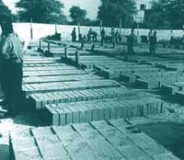
Waste generated from the aluminum industry is commonly known as red mud - used for making building materials:
- Aggregates, both dense and light weight by using red mud and fly ash;
- building bricks and flooring and walling tiles;
- Polymer composites for door panels, partitions etc;
- As cellular concrete additive/filler;
- Red mud light roofing sheets are already under production with imported technologies.
AGRICULTURAL WASTES
- RICE HUSK-
- The husk is made of hard materials, including opaline silica and lignin.
- Rice hulls are a class an insulating material because they are difficult to burn and less likely to allow moisture to propagate mold or fungi. For these reasons it provides excellent thermal insulation.
- In 1987, a house was built in Quezon City using Portland cement mixed with rice hull ash and lime as the main building material. The house was still standing in 2002.
- RICE HUSK ASH-
- The ash produced after the husks have been burned, is high in silica. A number of possible uses are being investigated for this. These uses include-
    - aggregates and fillers for concrete and board production
    - absorbents for oils and chemicals
    - soil ameliorants
    - as a source of silicon
- BAMBOO-
Bamboo is one of the oldest construction materials.

- JUTE STALKS & SUGARCANE TOPS-
- Jute stalks have been used to make a type of chip board.
- Development work on the application of heat and pressure to make lightweight boards from sugarcane tops.
- WOOD RESIDUES-
- Barks have been found to be a good source of lignin to produce a cheaper resin binder.
- Saw dust has been used with magnesium oxy-chloride cement binder to produce door and window frames.
- COCONUT WASTES –
- Waste coconut husk fibers are about 15 to 35 cm long and consist mainly of lignun and cellulose with about 10% pectin’s, tannins, and some water soluble substance.
- These fibers along with wood wool and cement as binder can be used to produce pressed building boards of roof height size or in a corrugated form as roofing sheet.
- This sheets cost less than half the A.C. sheet including cost of water and weather proofing treatment over time.
- Waste coconut nuts as such can be chipped off and hot pressed to produce particle boards.
Types of wastes in construction industry
- Construction or demolition waste, i.e., massive and inert waste
- Municipal waste, i.e., biodegradable and recyclable waste
- Hazardous waste,
- E-waste
Wastes generated in operational phase should be estimated and classified as
- Biodegradable
- Recyclable
- inert
- hazardous
Resource recovery
- The selective extraction of disposed materials for a specific next use, such as recycling, composting or energy generation.
- The aim of the resource recovery
    - to extract the maximum practical benefits from products,
    - delay the consumption of virgin natural resources
    - To generate the minimum amount of waste.
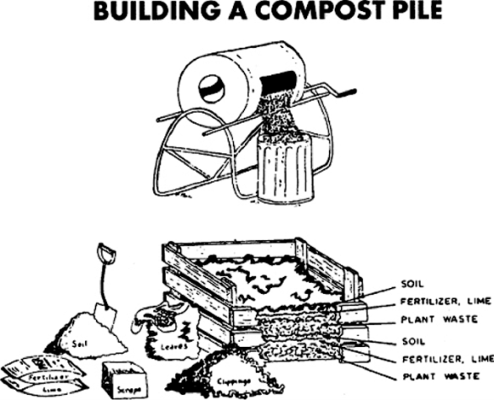
Composting
- Organic matter that has been decomposed and recycled as a fertilizer and soil amendment.
- The process of composting simply requires making a heap of wetted organic matter (leaves, "green" food waste) and waiting for the materials to break down into humus after a period of weeks or months.
- Modern, method - closely monitored process with measured inputs of water, air and carbon- and nitrogen-rich materials.
- Aided by shredding the plant matter, adding water and ensuring proper aeration by regularly turning the mixture.
Vermicompost
- the product or process of composting using various worms
- red wigglers, white worms, and other earthworms
- Worm humus or worm manure, is the end-product of the breakdown of organic matter by an earthworm.
BUILDING AN ENCLOSURE
- Enclosing the compost pile saves space and prevents litter.
- The enclosure should be collapsible or provide an entry large enough to permit the pile to be turned.
- It should measure at least 4'X4'X4' (optimum)
- The enclosure can be built of wood, pallets, hay bales, cinder blocks, stakes and chicken wire, or snow fencing.
- Prefabricated compost bins are also available.
BUILDING THE PILE
- Piles can be built in layers to ensure the proper proportion of carbon (e.g., leaves, woody materials) to nitrogen (grass, fertilizer), but the layers should be thoroughly intermixed after the pile is built.
MAINTENANCE
- Turning and mixing the pile with a pitchfork or shovel - provides the oxygen necessary for decomposition and compensates for excess moisture.
- Recommendations for mixing the pile vary from every 3 days to every 6 weeks.
- More frequent turning results in faster composting.
- Odors indicate that the pile is too damp or lacks oxygen, and that more frequent turning is necessary.
- Occasional watering may be necessary to keep the pile damp, especially in dry weather.
- Covering the pile with black plastic reduces the need for watering; it also prevents rainwater from leaching out the nutrients.
FINISHED COMPOST
- Finished compost is dark brown, crumbly, and has an earthy odor.
- Depending upon seasonal temperatures, a well-built, well-tended pile generally yields finished compost in 2 weeks to 4 months.

CASESTUDIES
Clematis House, Melbourne 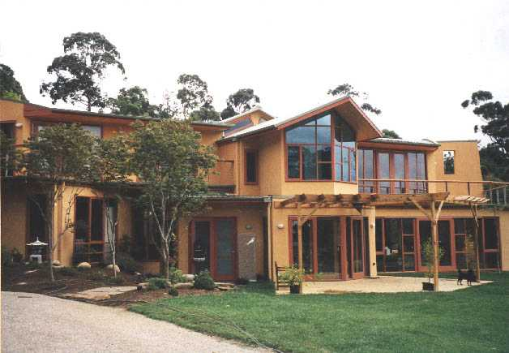
- a four-bedroom family home on a gentle sloping site
- Site area - 10 acres on a gentle ten-degree slope to the north-west
- The site has spectacular views over the Clematis valley - prime significance in the design.
- Temperatures as low as -5 Centigrade (internal comfort temperatures are designed to fall between 18 and 25 degrees Centigrade)
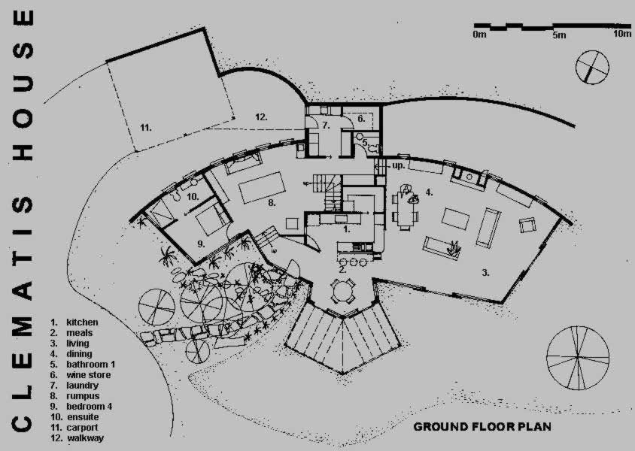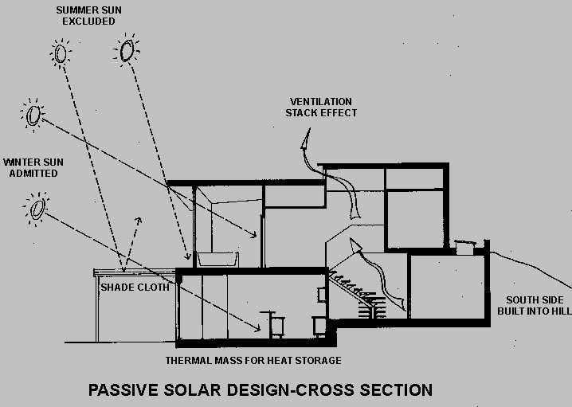
- highest point of the property -the spectacular views and to facilitate vehicular and services access from the existing road.
- Orientation - the building to approximately 15 degrees west of north ( to follow the line of the contours and to avoid overshadowing by the large adjacent trees)
- large areas of glazing to the north.
- North - habitable rooms to receive optimum solar access.
- ground floor – living areas with bedrooms on the upper floor set back from the line of the ground floor to form a north facing deck.
- An existing stand of trees has been retained to the south and west of the dwelling to act as a windbreak.
Kawanda Muna, Australia 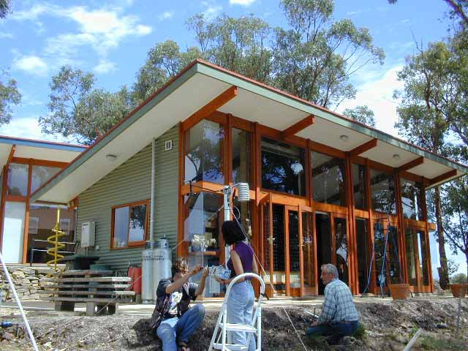
- Pre-design strategies - 'ecologically-sustainable' design by the owner
- Post-design and construction strategies
- The owner was involved in the construction of the house which occupied 2 tradesmen and 2 labourers for 6 months. Since the construction was completed, the owner has also been improving the house performance, for example by making a 'double-glazing effect' on the north-facing windows (by installing a plastic shrink-wrap), adding fly screens, ponds, and a sliding insulated door (polycarbonate) in the hallway to the back entry. A trombe wall with black CaCl2 panels which change phase at 28°C facing north was also installed at the kitchen end, which was monitored by the University of South Australia. A tracking set of 12 BP Saturn photovoltaic panels have also been installed and the owners keep track of how much electricity is produced through a monitoring device. In 2000 internal comfort (temperature and humidity) was measured / monitored in half-hour intervals by researchers from Adelaide University.
- Since its completion the building is also open for general public (by appointment) who are interested in building an environmentally-friendly home for themselves. Schools and young couples are amongst the people who often visit the house though tours for seniors have also been popular.
- Design strategies - used building materials, which had been collected over the years & rammed earth walls
Energy and Greenhouse gas emissions
1. Operational Energy a. Passive and Active Systems
i. Lighting: natural light during the day, compact fluorescent (16W, 24W, 26W and 36W) at night. Average lighting load is 2W/sqm in the living / dining block and 2.6W/sqm in the sleeping / bathroom block.
ii. Heating: Passive solar heat gain and a slow combustion heater (9.1kW, 71% efficiency) in the living space, with home grown wood. A radiator is sometimes used in the study room.
iii. Cooling: no mechanical cooling equipment
iv. Ventilation: Cross / natural ventilation. No fans installed.
v. Hot water: 6sqm solar collector with 380 litre water tank, connected to the slow combustion heater and an instant gas booster for the kitchen.
vi. Appliances and equipment: 378W dishwasher, 640W refrigerator, 237W washing machine (no electric clothes dryer), and a gas stove / oven.
vii. Power generation: 1kW photoivoltaic panels, connected to the grid and to the house. The house is also connected to the electricity grid.
viii. Energy source: gas (LPG) for cooking and backup for water heating, electricity for lights and appliances, wood for space heating.
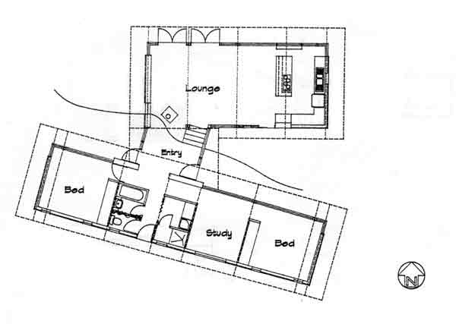
Energy and Greenhouse gas emissions |  | Environmental
Operational Energy | Embodied energy and life-cycle energy | Health - Air quality
Passive and Active Systems | Building materials were selected for their environmental, thermal, aesthetic as well as economical performance. | Grey water and black water: liquid wastes from kitchen and bathroom sinks as well as solid wastes from the toilet are collected in an earthworm run Dowmus Biolytic Filter (3000 litre)..
Comfort issues  Thermal comfort: Summer comfort is maintained through natural ventilation & inters comfort is maintained through passive solar heating and space heater at night  ii. Visual comfort: No glare | External walls - stabilised rammed earth (400mm thick for the east and west walls, 200mm thick for the north and south walls), and 90 mm concrete blocks for the south wall of the sleeping block and east wall of the kitchen | Appliances: dual flush toilet , low water use dish washer &

